UNITED STATES
SECURITIES AND EXCHANGE COMMISSION
WASHINGTON, D.C. 20549
________________
FORM 8-K
________________
CURRENT REPORT
PURSUANT TO SECTION 13 OR 15(D) OF
THE SECURITIES EXCHANGE ACT OF 1934
_____________________________
Date of Report (Date of earliest event reported): July 27, 2026
_____________________________
NORWOOD FINANCIAL CORP
(Exact Name of Registrant as Specified in its Charter)
________________
Pennsylvania | 0-28364 | 23-2828306
(State or Other Jurisdiction  ‎of Incorporation) | (Commission File Number) | (I.R.S. Employer  ‎Identification Number)
717 Main Street, Honesdale, Pennsylvania |  | 18431
(Address of Principal Executive Offices) |  | (Zip Code)
Registrant’s telephone number, including area code:(570) 253-1455
Not Applicable
(Former name or former address, if changed since last report)
________________
Check the appropriate box below if the Form 8-K filing is intended to simultaneously satisfy the filing obligation of the registrant under any of the following provisions (see General Instruction A.2. below):
☐ | Written communications pursuant to Rule 425 under the Securities Act (17 CFR 230.425)
☐ | Soliciting material pursuant to Rule 14a-12 under the Exchange Act (17 CFR 240.14a-12)
☐ | Pre-commencement communications pursuant to Rule 14d-2(b) under the Exchange Act (17 CFR 240.14d-2(b))
☐ | Pre-commencement communications pursuant to Rule 13e-4(c) under the Exchange Act (17 CFR 240.13e-4(c))
Securities registered pursuant to Section 12(b) of the Act:
Title of class |  | Trading  ‎symbol |  | Name of exchange on  ‎which registered
Common Stock, par value $0.10 per share |  | NWFL |  | The Nasdaq Stock Market LLC
Indicate by check mark whether the registrant is an emerging growth company as defined in Rule 405 of the Securities Act of 1933 (§230.405 of this chapter) or Rule 12b-2 of the Securities Exchange Act of 1934 (§240.12b-2 of this chapter).
Emerging growth company ☐
If an emerging growth company, indicate by check mark if the registrant has elected not to use the extended transition period for complying with any new or revised financial accounting standards provided pursuant to Section 13(a) of the Exchange Act. ☐
‎

NORWOOD FINANCIAL CORP
INFORMATION TO BE INCLUDED IN THE REPORT
Section 8 – Other Events
Item 7.01 Other Events.
Regulation FD Disclosure
The Company is furnishing materials included as Exhibit 99.1 to this report. These materials will be utilized by the Company during presentations made by the Company. The Company is not undertaking to update these materials. The information in this report (including Exhibit 99.1) is being furnished pursuant to Item 7.01 and shall not be deemed to be “filed” for purposes of Section 18 of the Securities Exchange Act of 1934, as amended, or otherwise subject to the liabilities of that section. This report will not be deemed an admission as to the materiality of any information herein (including Exhibit 99.1).
Section 9 – Financial Statements and Exhibits
Item 9.01 Financial Statements and Exhibits.
(d)The following exhibits are furnished with this report:
Exhibit  ‎No. |  | Description
99.1 |  | Investor Presentation dated July 27, 2026.
104 |  | The cover page for this Current Report on Form 8-K, formatted in Inline XBRL (included as Exhibit 101).
‎

SIGNATURES
Pursuant to the requirements of the Securities Exchange Act of 1934, the Registrant has duly caused this report to be signed on its behalf by the undersigned, hereunto duly authorized.
NORWOOD FINANCIAL CORP
 |  |  |  |  |  | NORWOOD FINANCIAL CORP
DATE: July 27, 2026 |  |  |  | By: |  | /s/ John M. McCaffery
 |  |  |  |  |  | John M. McCaffery
 |  |  |  |  |  | Executive Vice President and Chief Executive Officer
 |  |  |  |  |  | (Duly Authorized Representative)
Exhibit 99.1
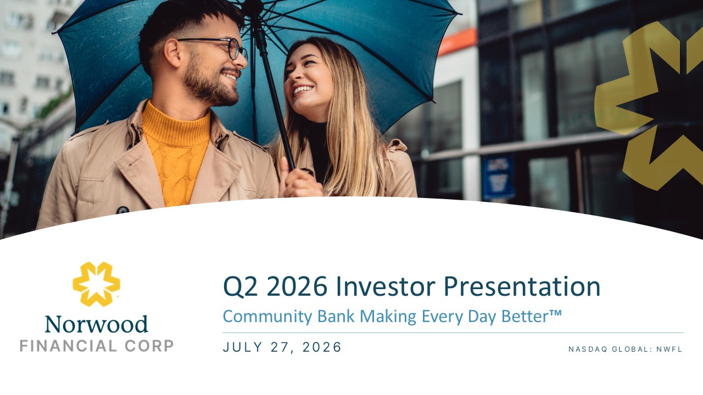
Q2 2026 Investor Presentation Community Bank Making Every Day Better™ JULY 27, 2026 Norwood FINANCIAL CORP

﻿
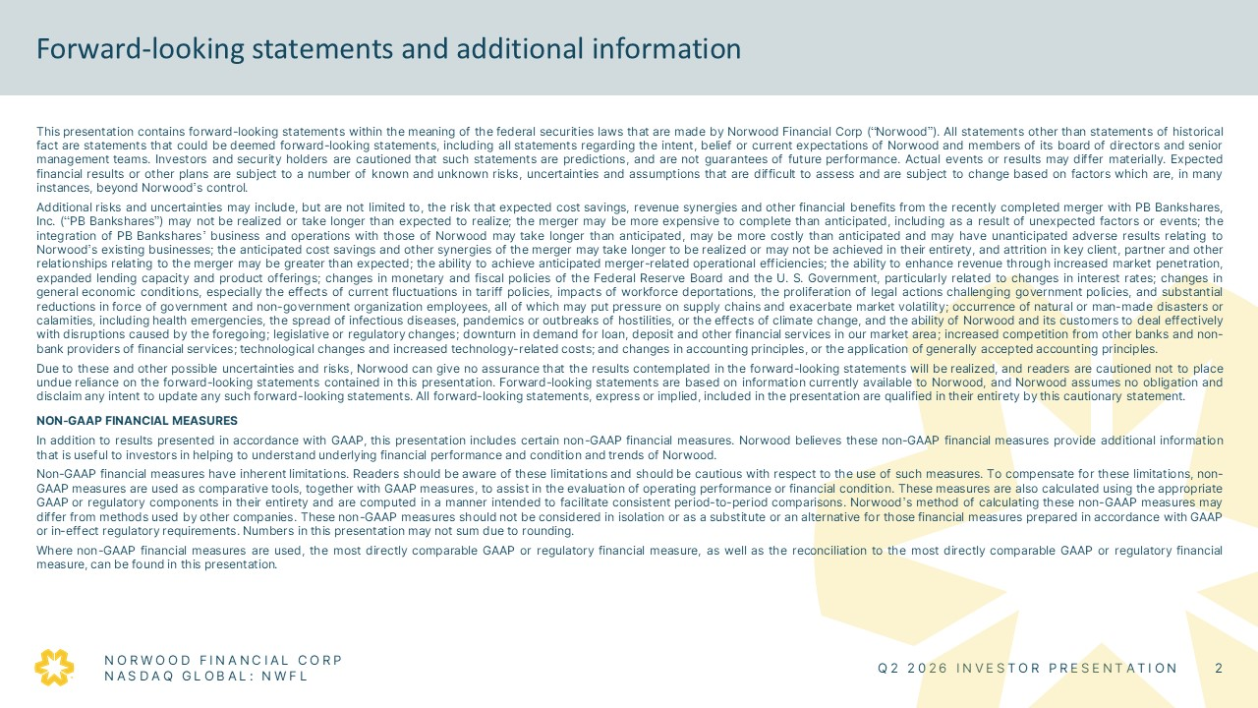
Forward-looking statements and additional information This presentation contains forward-looking statements within the meaning of the federal securities laws that are made by Norwood Financial Corp (“Norwood”). All statements other than statements of historical fact are statements that could be deemed forward-looking statements, including all statements regarding the intent, belief or current expectations of Norwood and members of its board of directors and senior management teams. Investors and security holders are cautioned that such statements are predictions, and are not guarantees of future performance. Actual events or results may differ materially. Expected financial results or other plans are subject to a number of known and unknown risks, uncertainties and assumptions that are difficult to assess and are subject to change based on factors which are, in many instances, beyond Norwood’s control. Additional risks and uncertainties may include, but are not limited to, the risk that expected cost savings, revenue synergies and other financial benefits from the recently completed merger with PB Bankshares, Inc. (“PB Bankshares”) may not be realized or take longer than expected to realize; the merger may be more expensive to complete than anticipated, including as a result of unexpected factors or events; the integration of PB Bankshares’ business and operations with those of Norwood may take longer than anticipated, may be more costly than anticipated and may have unanticipated adverse results relating to Norwood’s existing businesses; the anticipated cost savings and other synergies of the merger may take longer to be realized or may not be achieved in their entirety, and attrition in key client, partner and other relationships relating to the merger may be greater than expected; the ability to achieve anticipated merger-related operational efficiencies; the ability to enhance revenue through increased market penetration, expanded lending capacity and product offerings; changes in monetary and fiscal policies of the Federal Reserve Board and the U. S. Government, particularly related to changes in interest rates; changes in general economic conditions, especially the effects of current fluctuations in tariff policies, impacts of workforce deportations, the proliferation of legal actions challenging government policies, and substantial reductions in force of government and non-government organization employees, all of which may put pressure on supply chains and exacerbate market volatility; occurrence of natural or man-made disasters or calamities, including health emergencies, the spread of infectious diseases, pandemics or outbreaks of hostilities, or the effects of climate change, and the ability of Norwood and its customers to deal effectively with disruptions caused by the foregoing; legislative or regulatory changes; downturn in demand for loan, deposit and other financial services in our market area; increased competition from other banks and non-bank providers of financial services; technological changes and increased technology-related costs; and changes in accounting principles, or the application of generally accepted accounting principles. Due to these and other possible uncertainties and risks, Norwood can give no assurance that the results contemplated in the forward-looking statements will be realized, and readers are cautioned not to place undue reliance on the forward-looking statements contained in this presentation. Forward-looking statements are based on information currently available to Norwood, and Norwood assumes no obligation and disclaim any intent to update any such forward-looking statements. All forward-looking statements, express or implied, included in the presentation are qualified in their entirety by this cautionary statement. NON-GAAP FINANCIAL MEASURES In addition to results presented in accordance with GAAP, this presentation includes certain non-GAAP financial measures. Norwood believes these non-GAAP financial measures provide additional information that is useful to investors in helping to understand underlying financial performance and condition and trends of Norwood. Non-GAAP financial measures have inherent limitations. Readers should be aware of these limitations and should be cautious with respect to the use of such measures. To compensate for these limitations, non-GAAP measures are used as comparative tools, together with GAAP measures, to assist in the evaluation of operating performance or financial condition. These measures are also calculated using the appropriate GAAP or regulatory components in their entirety and are computed in a manner intended to facilitate consistent period-to-period comparisons. Norwood’s method of calculating these non-GAAP measures may differ from methods used by other companies. These non-GAAP measures should not be considered in isolation or as a substitute or an alternative for those financial measures prepared in accordance with GAAP or in-effect regulatory requirements. Numbers in this presentation may not sum due to rounding. Where non-GAAP financial measures are used, the most directly comparable GAAP or regulatory financial measure, as well as the reconciliation to the most directly comparable GAAP or regulatory financial measure, can be found in this presentation. NORWOOD FINANCIAL CORP NASDAQ GLOBAL: NWFL Q2 2026 INVESTOR PRESENTATION 2

﻿
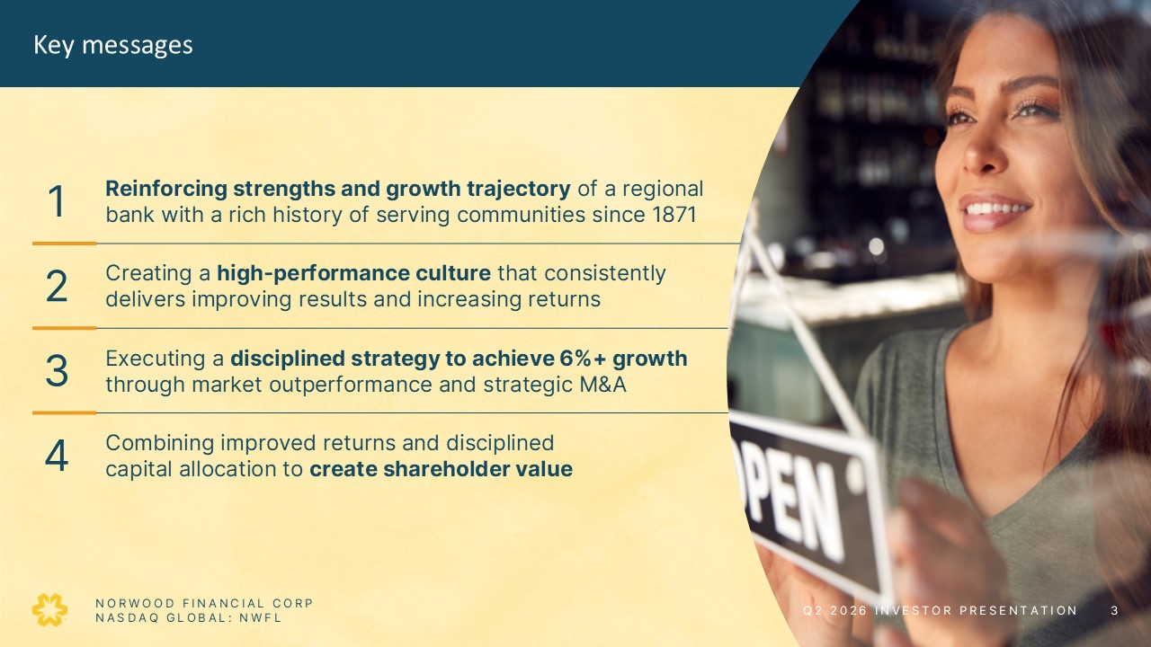
Key messages 1 Reinforcing strengths and growth trajectory of a regional bank with a rich history of serving communities since 1871 2 Creating a high-performance culture that consistently delivers improving results and increasing returns 3 Executing a disciplined strategy to achieve 6%+ growth through market outperformance and strategic M&A 4 Combining improved returns and disciplined capital allocation to create shareholder value NORWOOD FINANCIAL CORP NASDAQ GLOBAL: NWFL Q2 2026 INVESTOR PRESENTATION 3

﻿
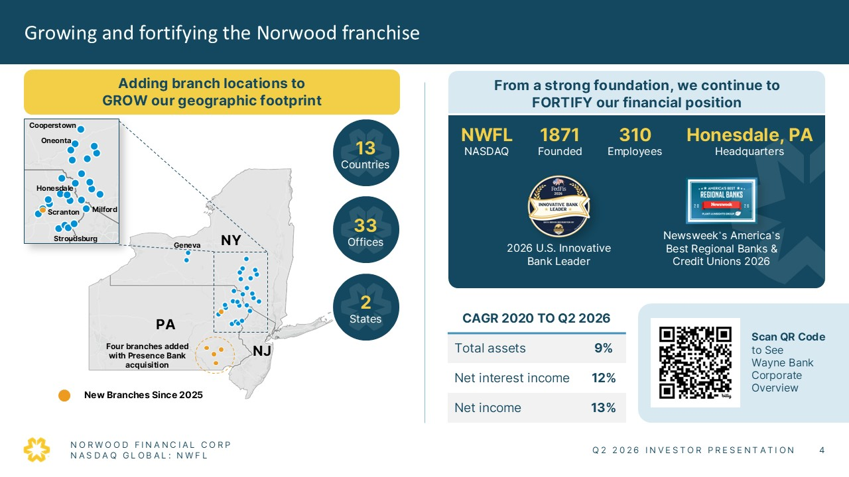
Growing and fortifying the Norwood franchise Adding branch locations to GROW our geographic footprint Cooperstown Honesdale Milford Stroudsburg Oneonta Scranton New Branches Since 2025 From a strong foundation, we continue to FORTIFY our financial position NWFL NASDAQ Honesdale, PA 13 Countries 33 Offices 2 States Headquarters 1871 Founded 310 Employees Scan QR Code to See Wayne Bank Corporate Overview CAGR 2020 TO Q2 2026 Total assets 9% Net interest income 12% Net income 13% NORWOOD FINANCIAL CORP NASDAQ GLOBAL: NWFL Q2 2026 INVESTOR PRESENTATION 4

﻿
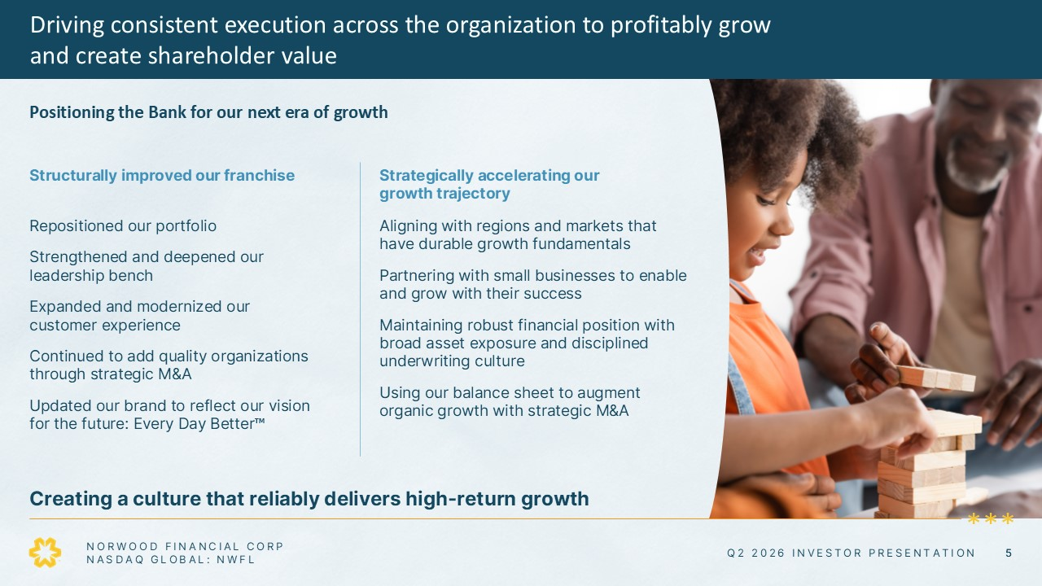
Driving consistent execution across the organization to profitably growand create shareholder value Positioning the Bank for our next era of growth Structurally improved our franchise Repositioned our portfolio Strengthened and deepened our leadership bench Expanded and modernized our customer experience Continued to add quality organizations through strategic M&A Updated our brand to reflect our vision for the future: Every Day Better™ Strategically accelerating our growth trajectory Aligning with regions and markets that have durable growth fundamentals Partnering with small businesses to enable and grow with their success Maintaining robust financial position with broad asset exposure and disciplined underwriting culture Using our balance sheet to augment organic growth with strategic M&A Creating a culture that reliably delivers high-return growth NORWOOD FINANCIAL CORP NASDAQ GLOBAL: NWFL Q2 2026 INVESTOR PRESENTATION 5

﻿
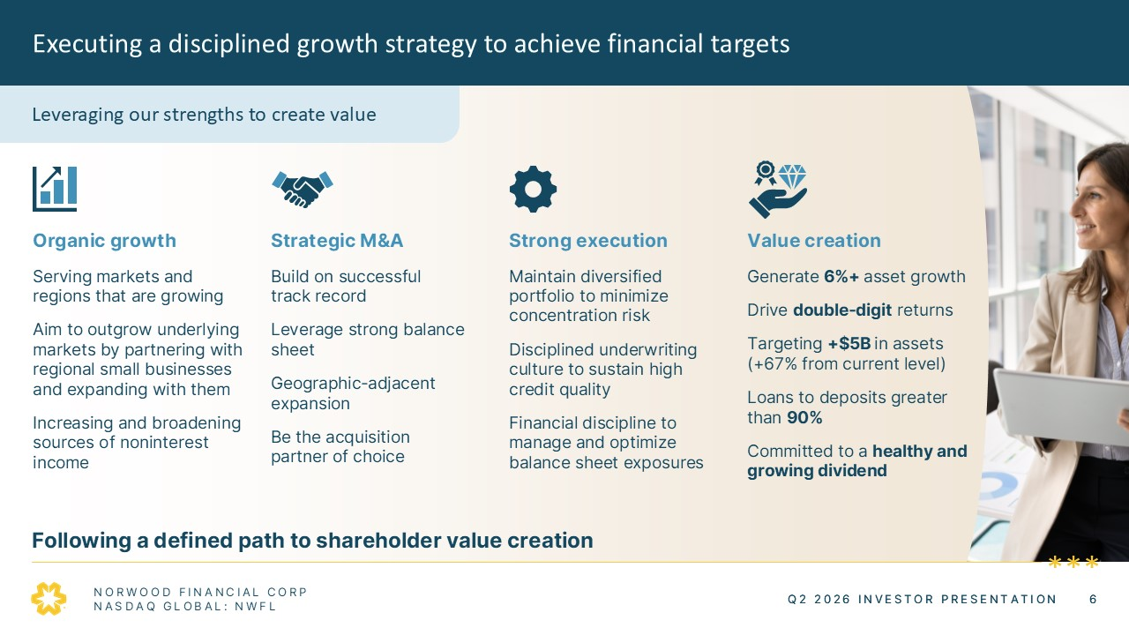
Executing a disciplined growth strategy to achieve financial targets Leveraging our strengths to create value Organic growth Serving markets and regions that are growing Aim to outgrow underlying markets by partnering with regional small businesses and expanding with them Increasing and broadening sources of noninterest income Strategic M&A Build on successful track record Leverage strong balance sheet Geographic-adjacent expansion Be the acquisition partner of choice Strong execution Maintain diversified portfolio to minimize concentration risk Disciplined underwriting culture to sustain high credit quality Financial discipline to manage and optimize balance sheet exposures Value creation Generate 6%+ asset growth Drive double-digit returns Targeting +$5B in assets (+67% from current level) Loans to deposits greater than 90% Committed to a healthy and growing dividend Following a defined path to shareholder value creation NORWOOD FINANCIAL CORP NASDAQ GLOBAL: NWFL Q2 2026 INVESTOR PRESENTATION 6

﻿
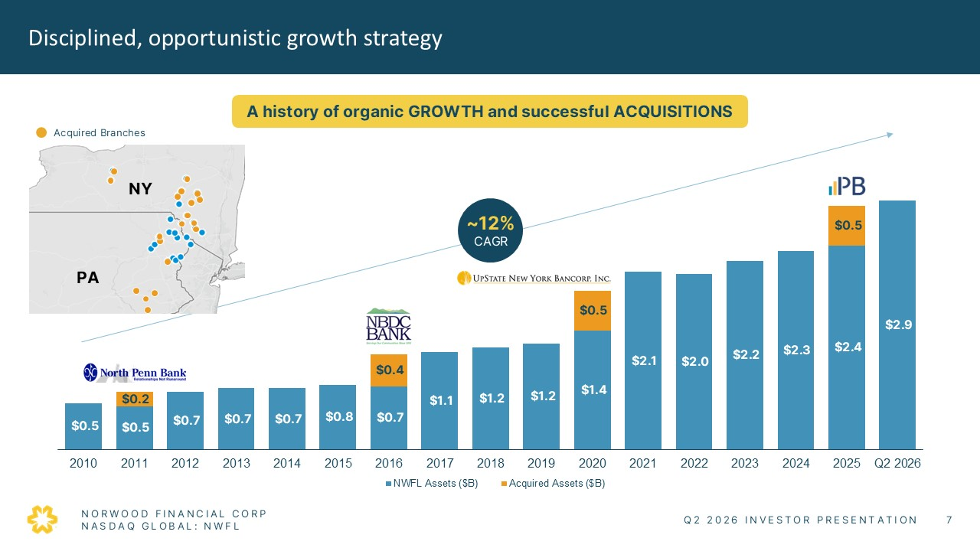
Disciplined, opportunistic growth strategy A history of organic GROWTH and successful ACQUISITIONS Acquired Brances ~12% CAGR $0.2 $0.4 $0.5 $0.5 $0.5 $0.5 $0.7 $0.7 $0.7 $0.8 $0.7 $1.1 $1.2 $1.2 $1.4 $2.1 $2.0 $2.2 $2.3 $2.4 $2.9 2010 2011 2012 2013 2014 2015 2016 2017 2018 2019 2020 2021 2022 2023 2024 2025 Q2 2026 NWFL Assets ($B) Acquired Assets ($B) NORWOOD FINANCIAL CORP NASDAQ GLOBAL: NWFL Q2 2026 INVESTOR PRESENTATION 7

﻿
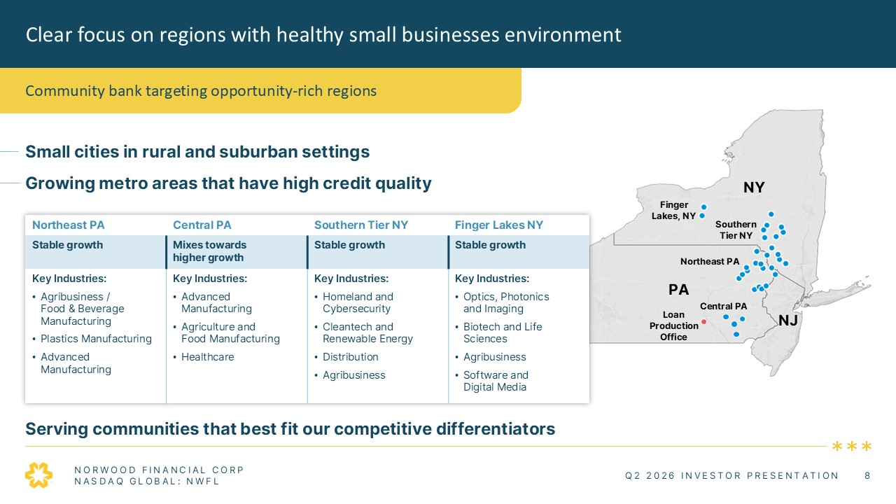
Clear focus on regions with healthy small businesses environment Community bank targeting opportunity-rich regions Small cities in rural and suburban settings Growing metro areas that have high credit quality Northeast PA Central PA Southern Tier NY Finger Lakes NY Stable growth Mixes towards higher growth Stable growth Stable growth Key Industries: • Agribusiness / Food & Beverage Manufacturing • Plastics Manufacturing • Advanced Manufacturing Key Industries: • Advanced Manufacturing • Agriculture and Food Manufacturing • Healthcare Key Industries: • Homeland and Cybersecurity • Cleantech and Renewable Energy • Distribution • Agribusiness Key Industries: • Optics, Photonics and Imaging • Biotech and Life Sciences • Agribusiness • Software and Digital Media Serving communities that best fit our competitive differentiators NORWOOD FINANCIAL CORP NASDAQ GLOBAL: NWFL Q2 2026 INVESTOR PRESENTATION 8

﻿
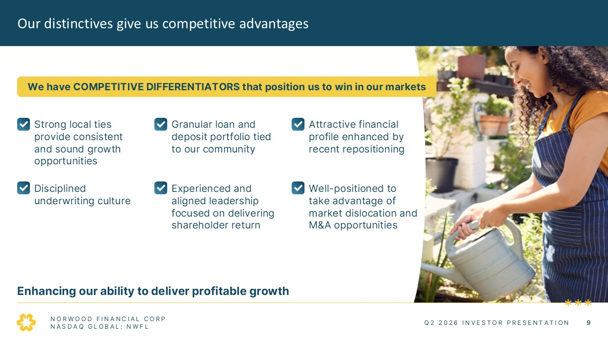
Our distinctives give us competitive advantages We have COMPETITIVE DIFFERENTIATORS that position us to win in our markets Strong local ties provide consistent and sound growth opportunities Granular loan and deposit portfolio tied to our community Attractive financial profile enhanced by recent repositioning Disciplined underwriting culture Experienced and aligned leadership focused on delivering shareholder return Well-positioned to take advantage of market dislocation and M&A opportunities Enhancing our ability to deliver profitable growth NORWOOD FINANCIAL CORP NASDAQ GLOBAL: NWFL Q2 2026 INVESTOR PRESENTATION 9

﻿
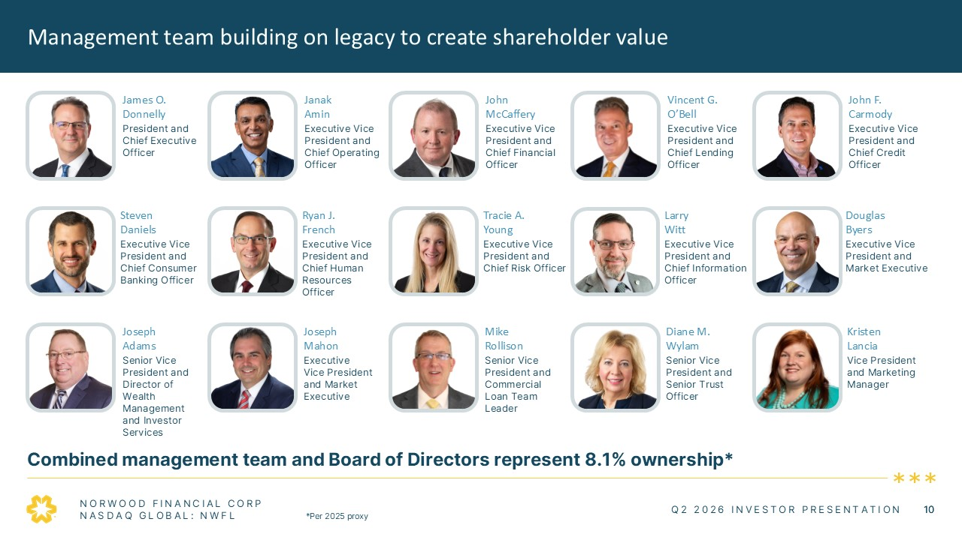
Management team building on legacy to create shareholder value James O. Donnelly Janak Amin John McCaffery Vincent G. O’Bell John F. Carmody President and Chief Executive Officer Executive Vice President and Chief Operating Officer Executive Vice President and Chief Financial Officer Executive Vice President and Chief Lending Officer Executive Vice President and Chief Credit Officer Steven Daniels Ryan J. French Tracie A. Young Larry Witt Douglas Byers Executive Vice President and Chief Consumer Banking Officer Executive Vice President and Chief Human Resources Officer Executive Vice President and Chief Risk Officer Executive Vice President and Chief Information Officer Executive Vice President and Market Executive Joseph Adams Joseph Mahon Mike Rollison Diane M. Wylam Kristen Lancia Senior Vice President and Director of Wealth Management and Investor Services Executive Vice President and Market Executive Senior Vice President and Commercial Loan Team Leader Senior Vice President and Senior Trust Officer Vice President and Marketing Manager Combined management team and Board of Directors represent 8.1% ownership* NORWOOD FINANCIAL CORP NASDAQ GLOBAL: NWFL *Per 2025 proxy Q2 2026 INVESTOR PRESENTATION 10

﻿
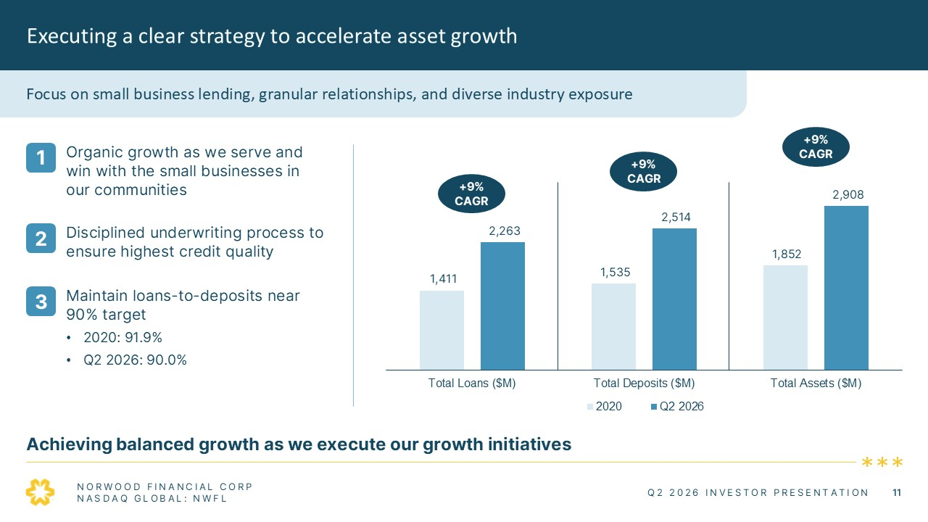
Executing a clear strategy to accelerate asset growth Focus on small business lending, granular relationships, and diverse industry exposure 1 Organic growth as we serve and win with the small businesses in our communities 2 Disciplined underwriting process to ensure highest credit quality 3 Maintain loans-to-deposits near 90% target 2020: 91.9% Q2 2026: 90.0% +9%CAGR +9%CAGR +9%CAGR 1,411 2,263 1,535 2,514 1,852 2,908 Total Loans ($M) Total Deposits ($M) Total Assets ($M) 2020 Q2 2026 Achieving balanced growth as we execute our growth initiatives NORWOOD FINANCIAL CORP NASDAQ GLOBAL: NWFL Q2 2026 INVESTOR PRESENTATION 11

﻿
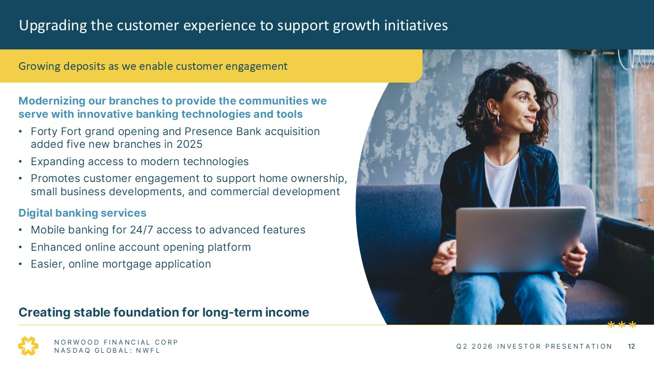
Upgrading the customer experience to support growth initiatives Growing deposits as we enable customer engagement Modernizing our branches to provide the communities we serve with innovative banking technologies and tools Forty Fort grand opening and Presence Bank acquisition added five new branches in 2025 Expanding access to modern technologies Promotes customer engagement to support home ownership, small business developments, and commercial development Digital banking services Mobile banking for 24/7 access to advanced features Enhanced online account opening platform Easier, online mortgage application Creating stable foundation for long-term income NORWOOD FINANCIAL CORP NASDAQ GLOBAL: NWFL Q2 2026 INVESTOR PRESENTATION 12

﻿
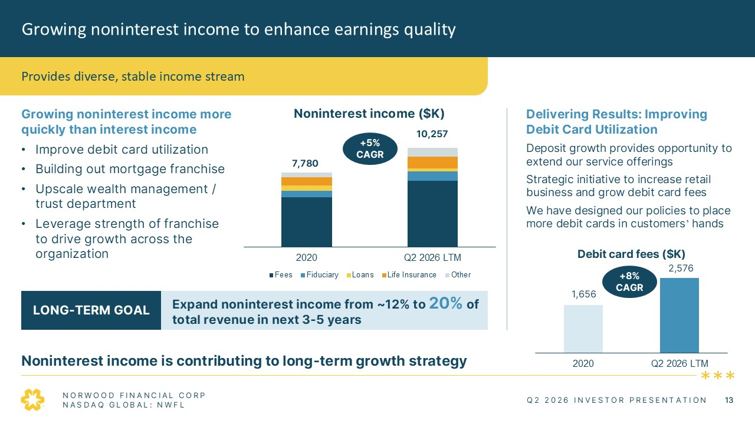
Growing noninterest income to enhance earnings quality Provides diverse, stable income stream Growing noninterest income more quickly than interest income Improve debit card utilization Building out mortgage franchise Upscale wealth management / trust department Leverage strength of franchise to drive growth across the organization Noninterest income ($K) +5%CAGR 7,780 10,257 2020 Q2 2026 LTM Fees Fiduciary Loans Life Insurance Other Delivering Results: Improving Debit Card Utilization Deposit growth provides opportunity to extend our service offerings Strategic initiative to increase retail business and grow debit card fees We have designed our policies to place more debit cards in customers’ hands Debit card fees ($K) 1,656 2,576 2020 Q2 2026 LTM +8%CAGR LONG-TERM GOAL Expand noninterest income from ~12% to 20% of total revenue in next 3-5 years Noninterest income is contributing to long-term growth strategy NORWOOD FINANCIAL CORP NASDAQ GLOBAL: NWFL Q2 2026 INVESTOR PRESENTATION 13

﻿
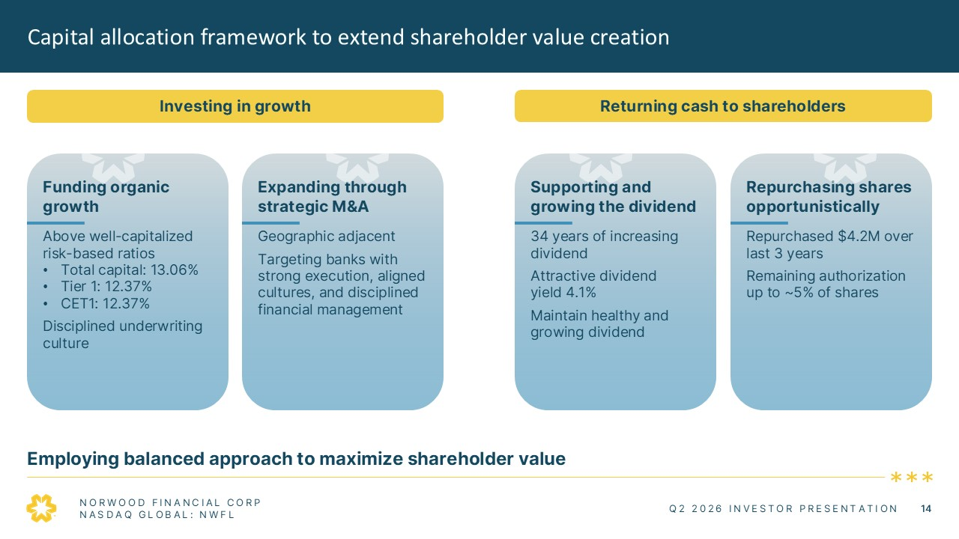
Capital allocation framework to extend shareholder value creation Investing in growth Funding organic growth Above well-capitalized risk-based ratios Total capital: 13.06% Tier 1: 12.37% CET1: 12.37% Disciplined underwriting culture Expanding through strategic M&A Geographic adjacent Targeting banks with strong execution, aligned cultures, and disciplined financial management Returning cash to shareholders Supporting and growing the dividend 34 years of increasing dividend Attractive dividend yield 4.1% Maintain healthy and growing dividend Repurchasing shares opportunistically Repurchased $4.2M over last 3 years Remaining authorization up to ~5% of shares Employing balanced approach to maximize shareholder value NORWOOD FINANCIAL CORP NASDAQ GLOBAL: NWFL Q2 2026 INVESTOR PRESENTATION 14

﻿
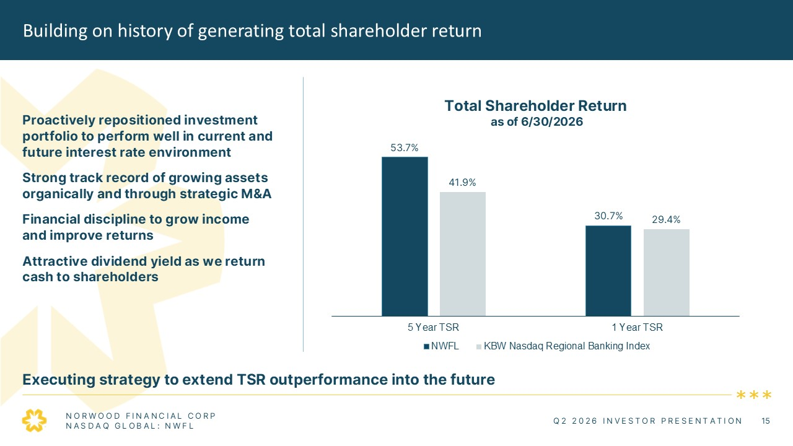
Building on history of generating total shareholder return Executing strategy to extend TSR outperformance into the future Proactively repositioned investment portfolio to perform well in current and future interest rate environment Strong track record of growing assets organically and through strategic M&A Financial discipline to grow income and improve returns Attractive dividend yield as we return cash to shareholders 53.7% 41.9% 30.7% 29.4% 5 Year TSR 1 Year TSR NWFL KBW Nasdaq Regional Banking Index NORWOOD FINANCIAL CORP NASDAQ GLOBAL: NWFL Q2 2026 INVESTOR PRESENTATION 15

﻿
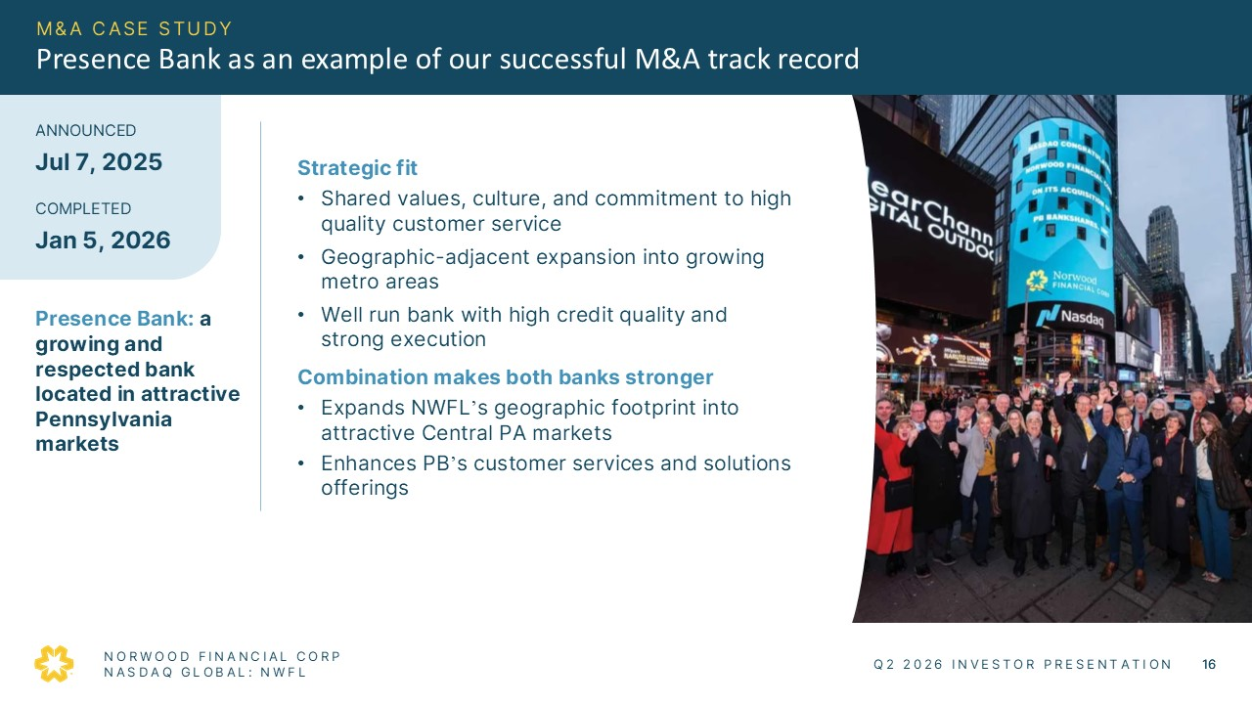
M&A CASE STUDY Presence Bank as an example of our successful M&A track record ANNOUNCED Jul 7, 2025 COMPLETED Jan 5, 2026 Presence Bank: a growing and respected bank located in attractive Pennsylvania markets Strategic fit Shared values, culture, and commitment to high quality customer service Geographic-adjacent expansion into growing metro areas Well run bank with high credit quality and strong execution Combination makes both banks stronger Expands NWFL’s geographic footprint into attractive Central PA markets Enhances PB’s customer services and solutions offerings NORWOOD FINANCIAL CORP NASDAQ GLOBAL: NWFL Q2 2026 INVESTOR PRESENTATION 16

﻿
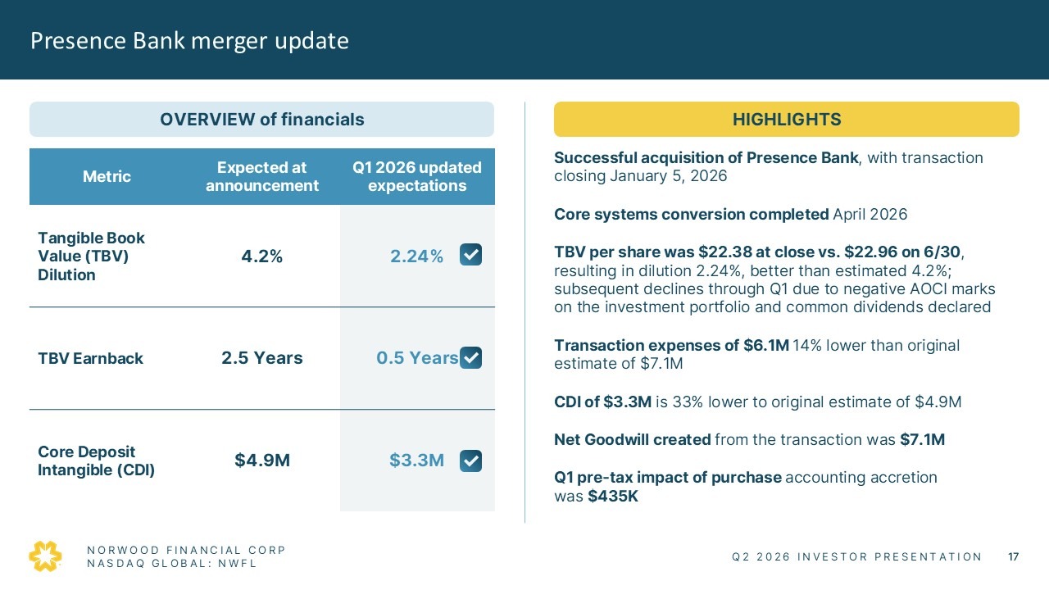
Presence Bank merger update OVERVIEW of financials Metric Expected at announcement Q1 2026 updated expectations Tangible Book Value (TBV) Dilution 4.2% 2.24% TBV Earnback 2.5 Years 0.5 Years Core Deposit Intangible (CDI) $4.9M $3.3M HIGHLIGHTS Successful acquisition of Presence Bank, with transaction closing January 5, 2026 Core systems conversion completed April 2026 TBV per share was $22.38 at close vs. $22.96 on 6/30, resulting in dilution 2.24%, better than estimated 4.2%; subsequent declines through Q1 due to negative AOCI marks on the investment portfolio and common dividends declared Transaction expenses of $6.1M 14% lower than original estimate of $7.1M CDI of $3.3M is 33% lower to original estimate of $4.9M Net Goodwill created from the transaction was $7.1M Q1 pre-tax impact of purchase accounting accretion was $435K NORWOOD FINANCIAL CORP NASDAQ GLOBAL: NWFL Q2 2026 INVESTOR PRESENTATION 17

﻿
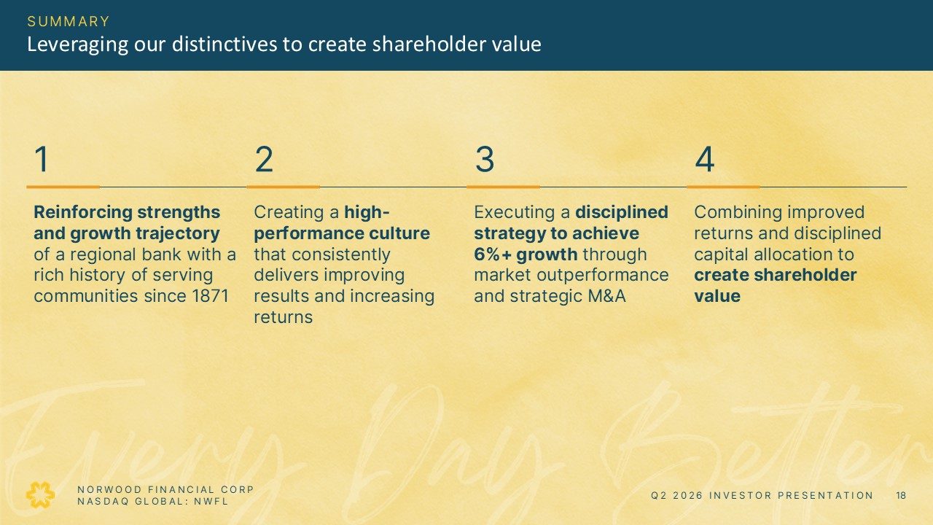
SUMMARY Leveraging our distinctives to create shareholder value 1 2 3 4 Reinforcing strengths and growth trajectory of a regional bank with a rich history of serving communities since 1871 Creating a high-performance culture that consistently delivers improving results and increasing returns Executing a disciplined strategy to achieve 6%+ growth through market outperformance and strategic M&A Combining improved returns and disciplined capital allocation to create shareholder value NORWOOD FINANCIAL CORP NASDAQ GLOBAL: NWFL Q2 2026 INVESTOR PRESENTATION 18

﻿

APPENDIX Q2 2026 INVESTOR PRESENTATION 19

﻿
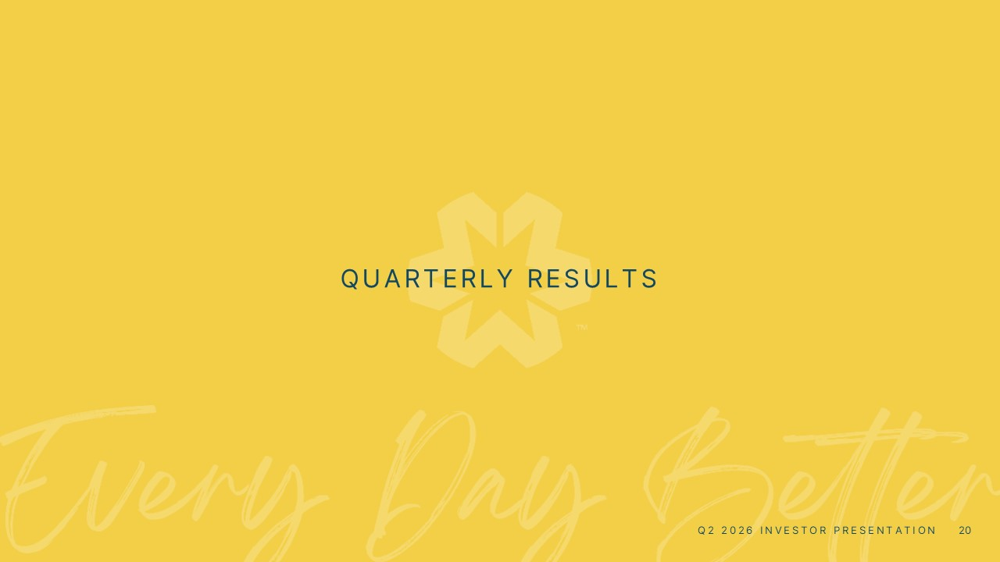
QUARTERLY RESULTS Q2 2026 INVESTOR PRESENTATION 20

﻿
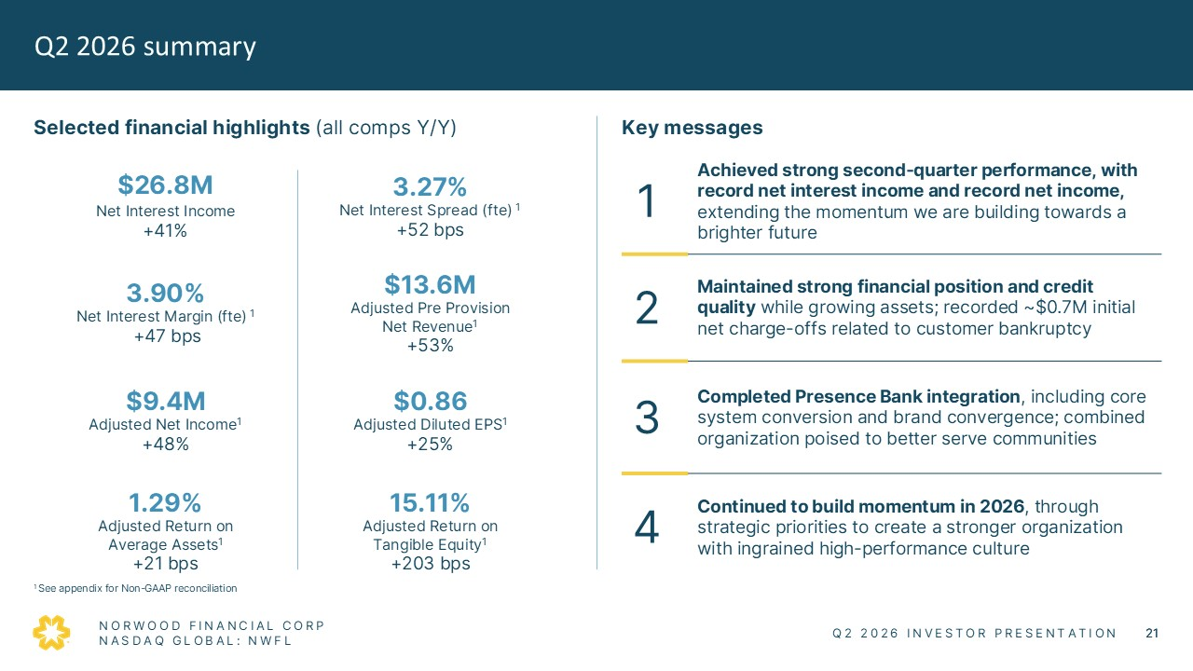
Q2 2026 summary Selected financial highlights (all comps Y/Y) $26.8M Net Interest Income +41% 3.27% Net Interest Spread (fte) 1 +52 bps 3.90% Net Interest Margin (fte) 1 +47 bps $13.6M Adjusted Pre Provision Net Revenue1 +53% $9.4M Adjusted Net Income1 +48% $0.86 Adjusted Diluted EPS1 +25% 1.29% Adjusted Return on Average Assets1 +21 bps 15.11% Adjusted Return on Tangible Equity1 +203 bps Key messages 1 Achieved strong second-quarter performance, with record net interest income and record net income, extending the momentum we are building towards a brighter future 2 Maintained strong financial position and credit quality while growing assets; recorded ~$0.7M initial net charge-offs related to customer bankruptcy 3 Completed Presence Bank integration, including core system conversion and brand convergence; combined organization poised to better serve communities 4 Continued to build momentum in 2026, through strategic priorities to create a stronger organization with ingrained high-performance culture 1 See appendix for Non-GAAP reconciliation NORWOOD FINANCIAL CORP NASDAQ GLOBAL: NWFL Q2 2026 INVESTOR PRESENTATION 21

﻿
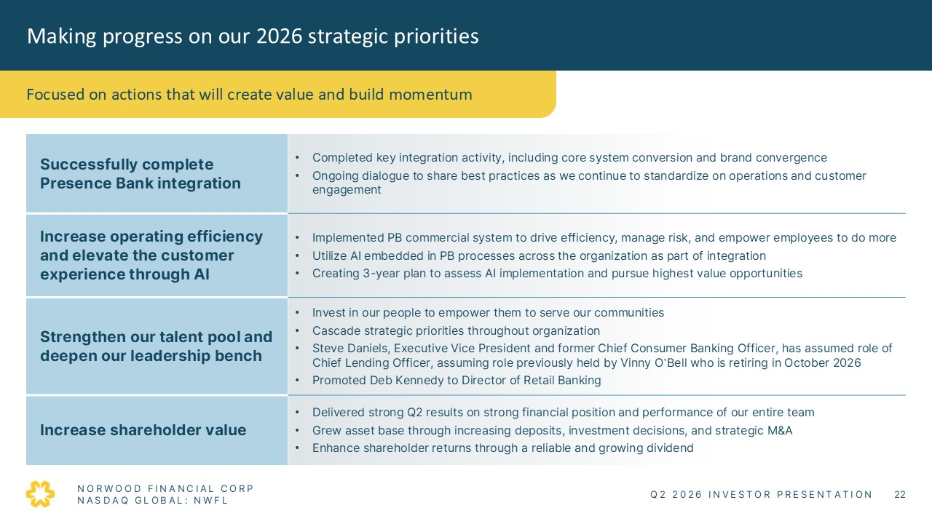
Making progress on our 2026 strategic priorities Focused on actions that will create value and build momentum Successfully complete Presence Bank integration • Completed key integration activity, including core system conversion and brand convergence • Ongoing dialogue to share best practices as we continue to standardize on operations and customer engagement Increase operating efficiency and elevate the customer experience through AI • Implemented PB commercial system to drive efficiency, manage risk, and empower employees to do more • Utilize AI embedded in PB processes across the organization as part of integration • Creating 3-year plan to assess AI implementation and pursue highest value opportunities Strengthen our talent pool and deepen our leadership bench • Invest in our people to empower them to serve our communities • Cascade strategic priorities throughout organization • Steve Daniels, Executive Vice President and former Chief Consumer Banking Officer, has assumed role of Chief Lending Officer, assuming role previously held by Vinny O’Bell who is retiring in October 2026 • Promoted Deb Kennedy to Director of Retail Banking Increase shareholder value • Delivered strong Q2 results on strong financial position and performance of our entire team • Grew asset base through increasing deposits, investment decisions, and strategic M&A • Enhance shareholder returns through a reliable and growing dividend NORWOOD FINANCIAL CORP NASDAQ GLOBAL: NWFL Q2 2026 INVESTOR PRESENTATION 22

﻿
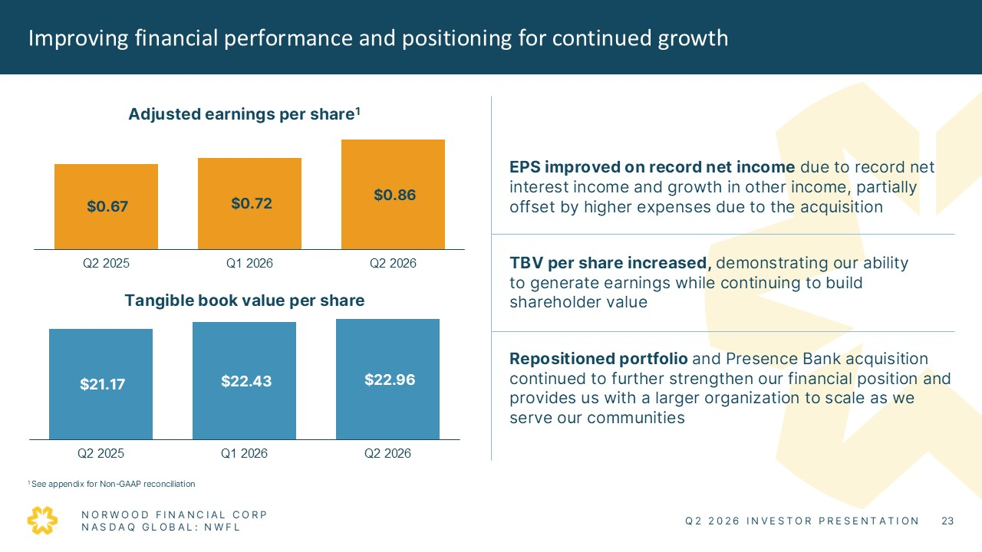
Improving financial performance and positioning for continued growth Adjusted earnings per share1 $0.67 $0.72 $0.86 Q2 2025 Q1 2026 Q2 2026 Tangible book value per share $21.70 $22.43 $22.96 Q2 2025 Q1 2026 Q2 2026 EPS improved on record net income due to record net interest income and growth in other income, partially offset by higher expenses due to the acquisition TBV per share increased, demonstrating our ability to generate earnings while continuing to build shareholder value Repositioned portfolio and Presence Bank acquisition continued to further strengthen our financial position and provides us with a larger organization to scale as we serve our communities 1 See appendix for Non-GAAP reconciliation NORWOOD FINANCIAL CORP NASDAQ GLOBAL: NWFL Q2 2026 INVESTOR PRESENTATION 23

﻿
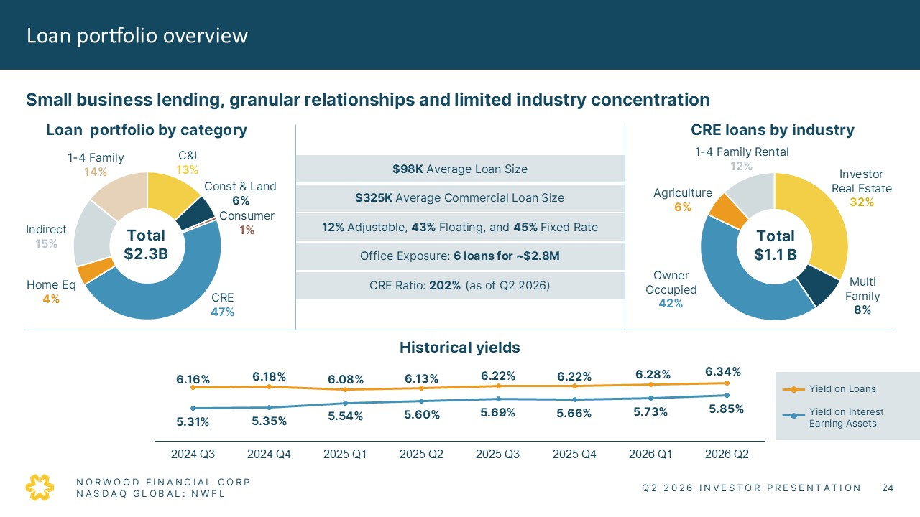
Loan portfolio overview Small business lending, granular relationships and limited industry concentration Loan portfolio by category 1-4 Family 14% C&I 13% Const & Land 6% Consumer 1% CRE 47% Home Eq 4% Indirect 15% Total $2.3B $98K Average Loan Size 12% Adjustable, 43% Floating, and 45% Fixed Rate Office Exposure: 6 loans for ~$2.8M CRE Ratio: 202% (as of Q2 2026) $325K Average Commercial Loan Size CRE loans by industry 1-4 Family Rental 12% Investor Real Estate 32% Multi Family 8% Owner Occupied 42% Agriculture 6% Total $1.1B Historical yields 6.16% 6.18% 6.08% 6.13% 6.22% 6.22% 6.28% 6.34% 5.31% 5.35% 5.54% 5.60% 5.69% 5.66% 5.73% 5.85% 2024 Q3 2024 Q4 2025 Q1 2025 Q2 2025 Q3 2025 Q4 2026 Q1 2026 Q2 Yield on Loans Yield on Interest Earning Assets NORWOOD FINANCIAL CORP NASDAQ GLOBAL: NWFL Q2 2026 INVESTOR PRESENTATION 24

﻿
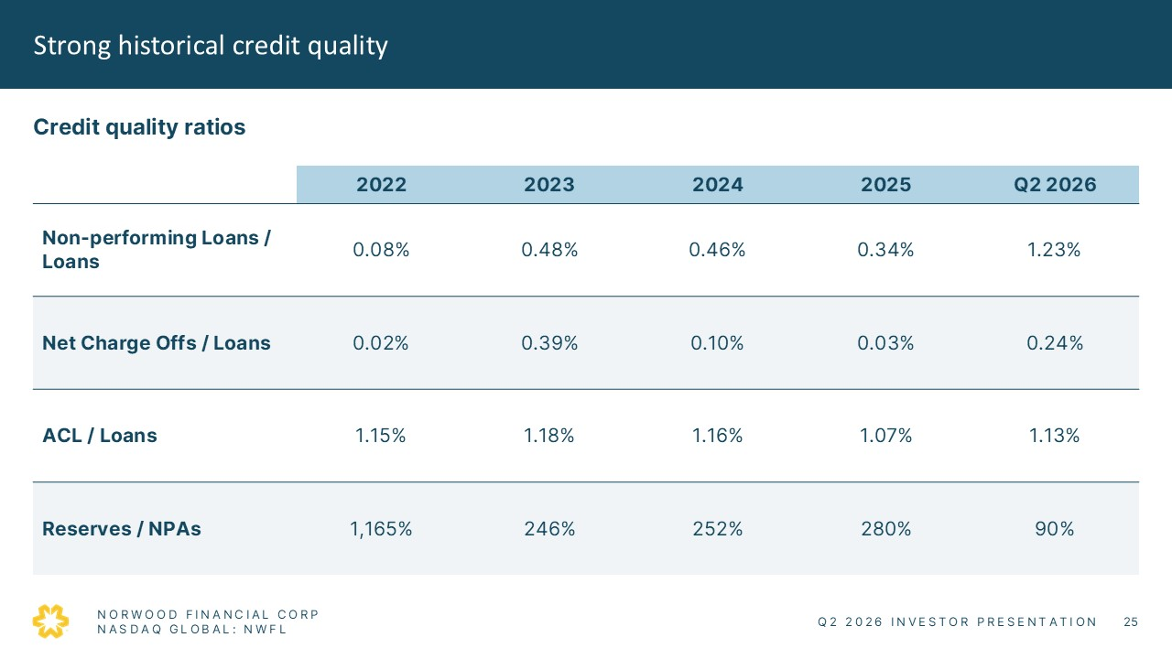
Strong historical credit quality Credit quality ratios 2022 2023 2024 2025 Q2 2026 Non-performing Loans / Loans 0.08% 0.48% 0.46% 0.34% 1.23% Net Charge Offs / Loans 0.02% 0.39% 0.10% 0.03% 0.24% ACL / Loans 1.15% 1.18% 1.16% 1.07% 1.13% Reserves / NPAs 1,165% 246% 252% 280% 90% NORWOOD FINANCIAL CORP NASDAQ GLOBAL: NWFL Q2 2026 INVESTOR PRESENTATION 25

﻿
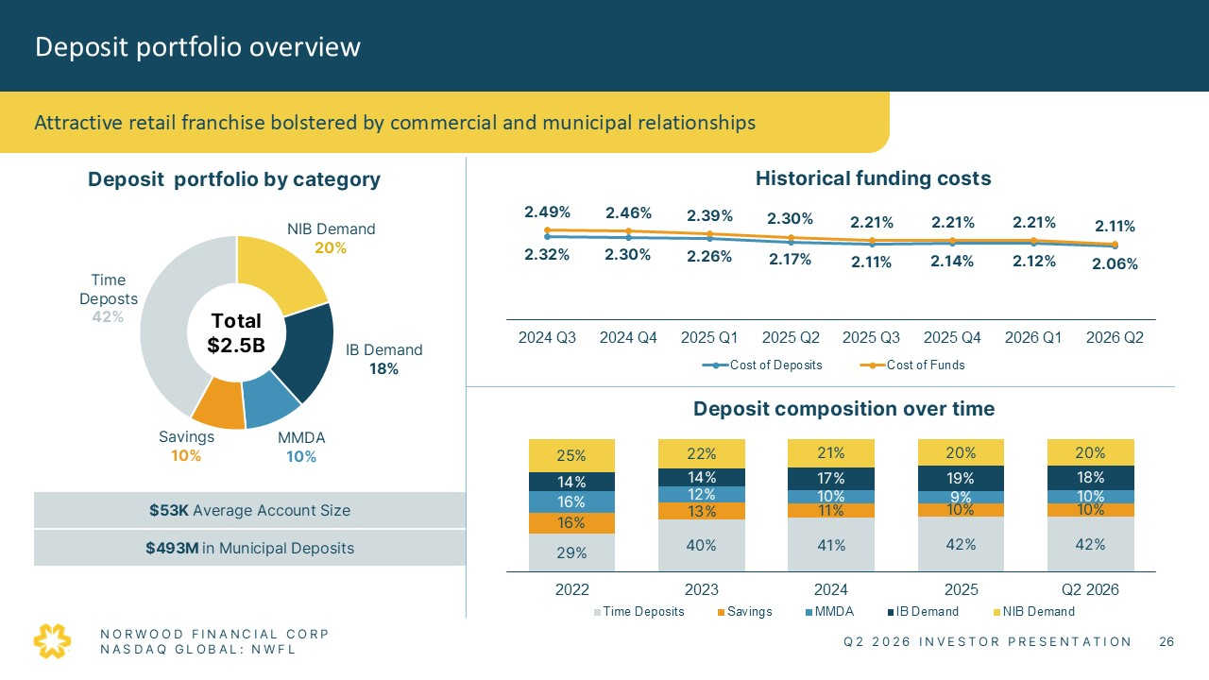
Deposit portfolio overview Attractive retail franchise bolstered by commercial and municipal relationships Deposit portfolio by category NIB Demand 20% IB Demand 18% MMDA 10% Savings 10% Time Deposits 42%Total $2.5B $53K Average Account Size $493M in Municipal Deposits Historical funding costs 2.49% 2.46% 2.39% 2.30% 2.21% 2.21% 2.21% 2.11% 2.32% 2.30% 2.26% 2.27% 2.11% 2.14% 2.12% 2.06% 2024 Q3 2024 Q4 2025 Q1 2025 Q2 2025 Q3 2025 Q4 2026 Q1 2026 Q2 Cost of Deposits Cost of F unds Deposit composition over time 25% 22% 21% 20% 20% 14% 14% 17% 19% 18% 16% 12% 10% 9% 10% 16% 13% 11% 10% 10% 29% 40% 41% 42% 42% 2022 2023 2024 2025 Q2 2026 Time Deposits Savings MMDA IB Demand NIB Demand NORWOOD FINANCIAL CORP NASDAQ GLOBAL: NWFL Q2 2026 INVESTOR PRESENTATION 26

﻿
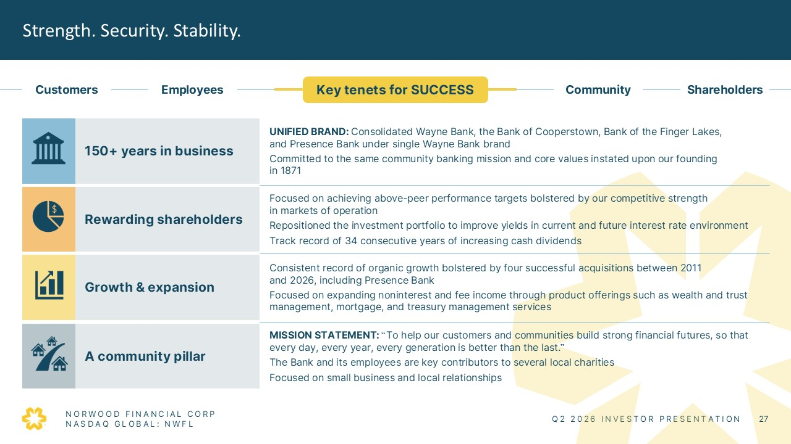
Strength. Security. Stability. Customers Employees Key tenets for SUCCESS Community Shareholders 150+ years in business UNIFIED BRAND: Consolidated Wayne Bank, the Bank of Cooperstown, Bank of the Finger Lakes, and Presence Bank under single Wayne Bank brand Committed to the same community banking mission and core values instated upon our founding in 1871 Rewarding shareholders Focused on achieving above-peer performance targets bolstered by our competitive strength in markets of operation Repositioned the investment portfolio to improve yields in current and future interest rate environment Track record of 34 consecutive years of increasing cash dividends Growth & expansion Consistent record of organic growth bolstered by four successful acquisitions between 2011 and 2026, including Presence Bank Focused on expanding noninterest and fee income through product offerings such as wealth and trust management, mortgage, and treasury management services A community pillar MISSION STATEMENT: “To help our customers and communities build strong financial futures, so that every day, every year, every generation is better than the last.” The Bank and its employees are key contributors to several local charities Focused on small business and local relationships NORWOOD FINANCIAL CORP NASDAQ GLOBAL: NWFL Q2 2026 INVESTOR PRESENTATION 27

﻿

NON-GAAP RECONCILIATIONS Q2 2026 INVESTOR PRESENTATION 28

﻿
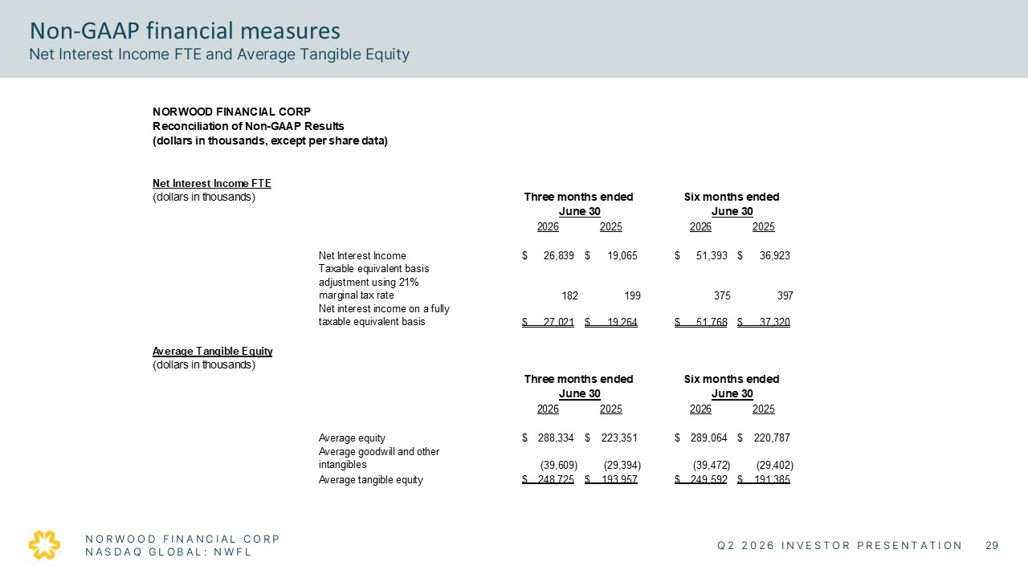
Non-GAAP financial measures Net Interest Income FTE and Average Tangible Equity FINANCIAL CORP Reconciliation of Non-GAAP Results (dollars in thousands, except per share data) Net Interest Income FTE (dollars in thousands) Three months ended June 30 Six months ended June 30 2026 2025 2026 2025 Net Interest Income $ 26,839 $ 19,065 $ 51,393 $ 36,923 Taxable equivalent basis adjustment using 21% marginal tax rate 182 199 375 397 Net interest income on a fully taxable equivalent basis $ 27,021 $ 19,264 $ 51,768 $ 37,320 Average Tangible Equity (dollars in thousands) Three months ended June 30 Six months ended June 30 2026 2025 2026 2025 Average equity $ 288,334 $ 223,351 $ 289,064 $ 220,787 Average goodwill and other intangibles (39,609) (29,394) (39,472) (29,402) Average tangible equity $ 248,725 $ 193,957 $ 249,592 $ 191,385 NORWOOD FINANCIAL CORP NASDAQ GLOBAL: NWFL Q2 2026 INVESTOR PRESENTATION 29

﻿
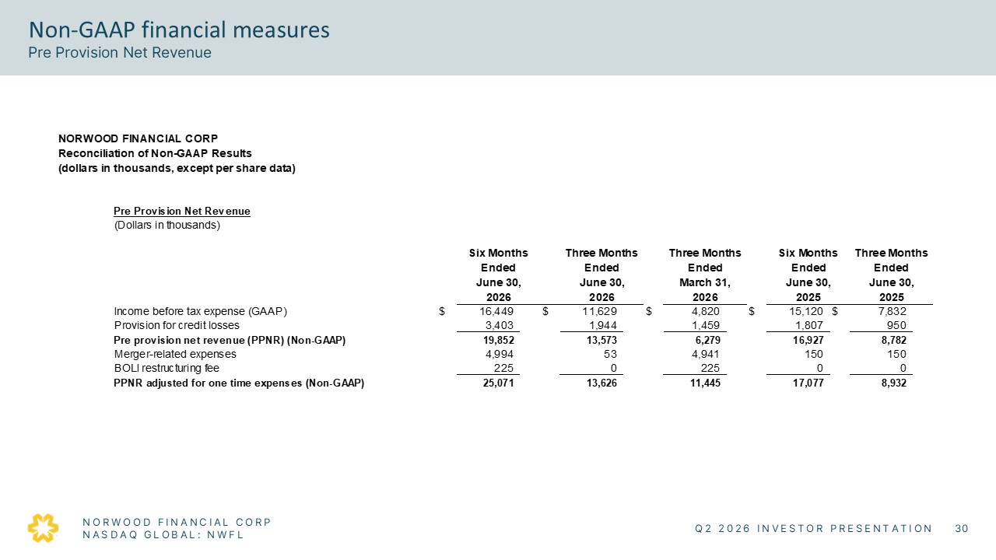
Non-GAAP financial measures Pre Provision Net Revenue Pre Provision Net Revenue (Dollars in thousands) Six Months Ended June 30, 2026 Three Months Ended June 30, 2026 Three Months Ended March 31, 2026 Six Months Ended June 30, 2025 Three Months Ended June 30, 2025 Income before tax expense (GAAP) $ 16,449 $ 11,629 $ 4,820 $ 15,120 $ 7,832 Provision for credit losses 3,403 1,944 1,459 1,807 950 Pre provision net revenue (PPNR) (Non-GAAP) 19,852 13,573 6,279 16,927 8,782 Merger-related expenses 4,994 53 4,941 150 150 BOLI restructuring fee 225 — 225 — — PPNR adjusted for one time expenses (Non-GAAP) 25,071 13,626 11,445 17,077 8,932 NORWOOD FINANCIAL CORP NASDAQ GLOBAL: NWFL Q2 2026 INVESTOR PRESENTATION 30

﻿
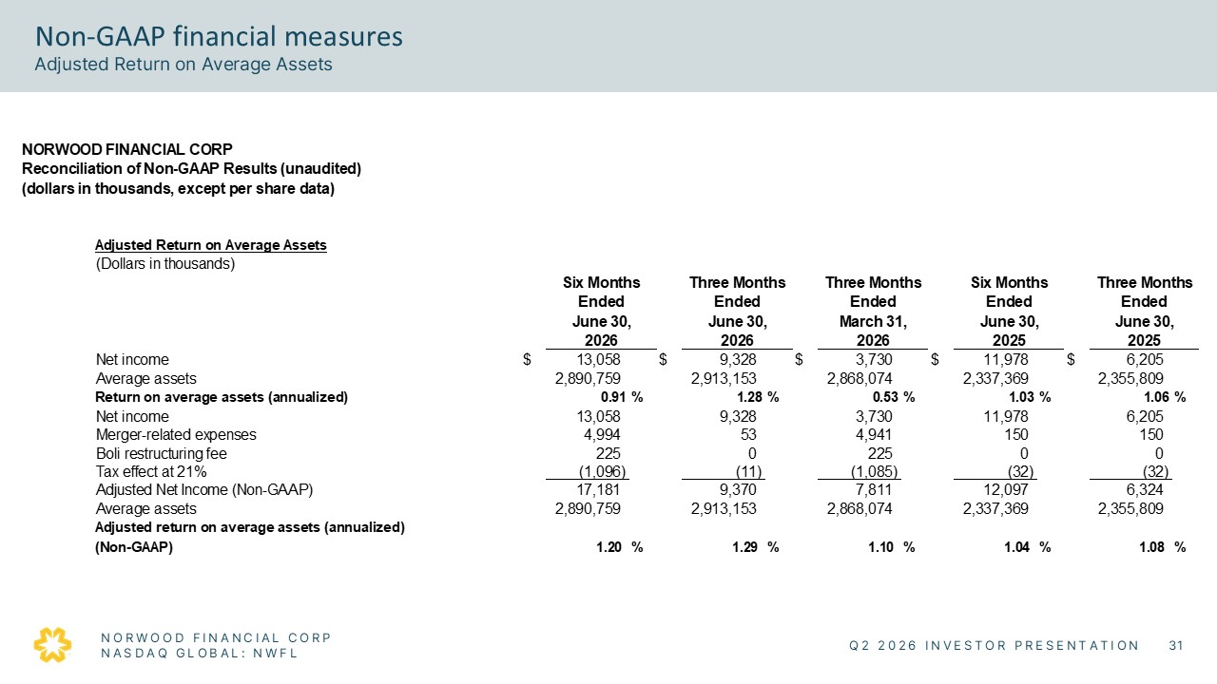
Non-GAAP financial measures Adjusted Return on Average Assets NORWOOD FINANCIAL CORP Reconciliation of Non-GAAP Results (unaudited) (dollars in thousands, except per share data) Adjusted Return on Average Assets (Dollars in thousands) Six Months Ended June 30, 2026 Three Months Ended June 30, 2026 Three Months Ended March 31, 2026 Six Months Ended June 30, 2025 Three Months Ended June 30, 2025 Net income $ 13,058 $ 9,328 $ 3,730 $ 11,978 $ 6,205 Average assets 2,890,759 2,913,153 2,868,074 2,337,369 2,355,809 Return on average assets (annualized) 0.91% 1.28% 0.53% 1.03% 1.06% Net income 13,058 9,328 3,730 11,978 6,205 Merger-related expenses 4,994 53 4,941 150 150 Boli restructuring fee 225 0 225 0 0 Tax effect at 21% (1,096) (11) (1,085) (32) (32) Adjusted Net Income (Non-GAAP) 17,181 9,370 7,811 12,097 6,324 Average assets 2,890,759 2,913,153 2,868,074 2,337,369 2,355,809 Adjusted return on average assets (annualized) (Non-GAAP) 1.20% 1.29% 1.10% 1.04% 1.08% NORWOOD FINANCIAL CORP NASDAQ GLOBAL: NWFL Q2 2026 INVESTOR PRESENTATION 31

﻿
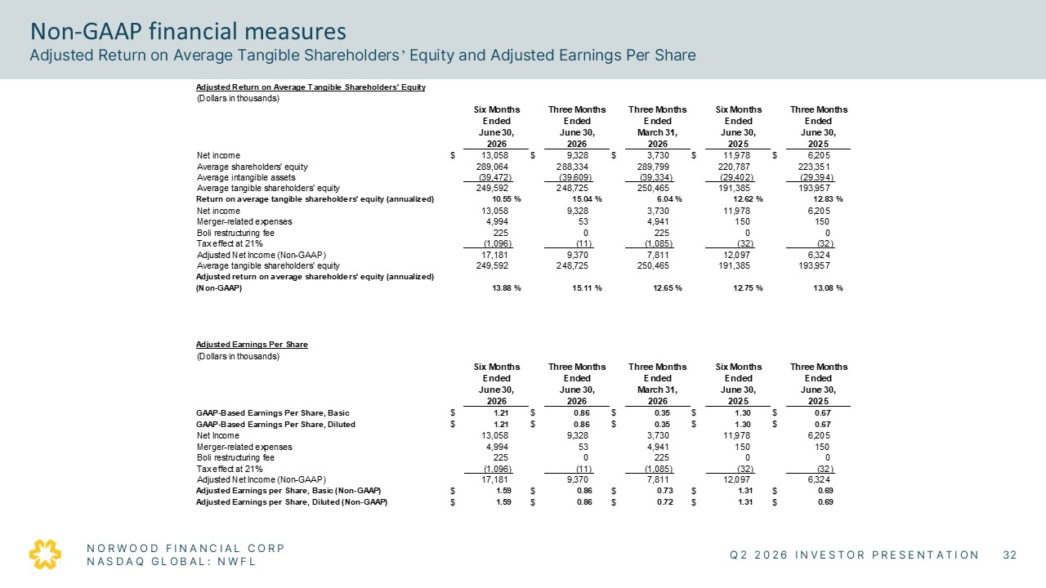
Non-GAAP financial measures Adjusted Return on Average Tangible Shareholders’ Equity and Adjusted Earnings Per Share Adjusted Return on Average Tangible Shareholders' Equity (Dollars in thousands) Six Months Ended June 30, 2026 Three Months Ended June 30, 2026 Three Months Ended March 31, 2026 Six Months Ended June 30, 2025 Three Months Ended June 30, 2025 Net income $ 13,058 $ 9,328 $ 3,730 $ 11,978 $ 6,205 Average shareholders' equity 289,064 288,334 289,790 220,787 223,351 Average intangible assets (39,472) (39,609) (39,394) (29,402) (29,394) Average tangible shareholders' equity 249,592 248,725 250,465 191,385 193,957 Return on average tangible shareholders' equity (annualized) 10.55% 15.04% 6.04% 12.62% 12.83% Net income 13,058 9,328 3,730 11,978 6,205 Merger-related expenses 4,994 53 4,941 150 150 Boli restructuring fee 225 0 225 0 0 Tax effect at 21% (1,096) (11) (1,085) (32) (32) Adjusted Net Income (Non-GAAP) 17,181 9,370 7,811 12,097 6,324 Average tangible shareholders' equity 249,592 248,725 250,465 191,385 193,957 Adjusted return on average shareholders' equity (annualized) (Non-GAAP) 13.88% 15.11% 12.65% 12.75% 13.08% Adjusted Earnings Per Share (Dollars in thousands) Six Months Ended June 30, 2026 Three Months Ended June 30, 2026 Three Months Ended March 31, 2026 Six Months Ended June 30, 2025 Three Months Ended June 30, 2025 GAAP-Based Earnings Per Share, Basic $ 1.21 $ 0.86 $ 0.35 $ 1.30 $ 0.67 GAAP-Based Earnings Per Share, Diluted $ 1.21 $ 0.86 $ 0.35 $ 1.30 $ 0.67 Net income 13,058 9,328 3,730 11,978 6,205 Merger-related expenses 4,994 53 4,941 150 150 Boli restructuring fee 225 0 225 0 0 Tax effect at 21% (1,096) (11) (1,085) (32) (32) Adjusted Net Income (Non-GAAP) 17,181 9,370 7,811 12,097 6,324 Adjusted Earnings per Share, Basic (Non-GAAP) $ 1.59 $ 0.86 $ 0.73 $ 1.31 $ 0.69 Adjusted Earnings per Share, Diluted (Non-GAAP) $ 1.59 $ 0.86 $ 0.72 $ 1.31 $ 0.69 NORWOOD FINANCIAL CORP NASDAQ GLOBAL: NWFL Q2 2026 INVESTOR PRESENTATION 32

﻿

Thank you

