UNITED STATES
SECURITIES AND EXCHANGE COMMISSION
WASHINGTON, D.C. 20549
________________
FORM 8-K
________________
CURRENT REPORT
PURSUANT TO SECTION 13 OR 15(D) OF
THE SECURITIES EXCHANGE ACT OF 1934
_____________________________
Date of Report (Date of earliest event reported): July 22, 2026
_____________________________
NORWOOD FINANCIAL CORP
(Exact Name of Registrant as Specified in its Charter)
________________
Pennsylvania | 0-28364 | 23-2828306
(State or Other Jurisdiction  ‎of Incorporation) | (Commission File Number) | (I.R.S. Employer  ‎Identification Number)
717 Main Street, Honesdale, Pennsylvania |  | 18431
(Address of Principal Executive Offices) |  | (Zip Code)
Registrant’s telephone number, including area code:(570) 253-1455
Not Applicable
(Former name or former address, if changed since last report)
________________
Check the appropriate box below if the Form 8-K filing is intended to simultaneously satisfy the filing obligation of the registrant under any of the following provisions (see General Instruction A.2. below):
☐ | Written communications pursuant to Rule 425 under the Securities Act (17 CFR 230.425)
☐ | Soliciting material pursuant to Rule 14a-12 under the Exchange Act (17 CFR 240.14a-12)
☐ | Pre-commencement communications pursuant to Rule 14d-2(b) under the Exchange Act (17 CFR 240.14d-2(b))
☐ | Pre-commencement communications pursuant to Rule 13e-4(c) under the Exchange Act (17 CFR 240.13e-4(c))
Securities registered pursuant to Section 12(b) of the Act:
Title of class |  | Trading  ‎symbol |  | Name of exchange on  ‎which registered
Common Stock, $0.10 par value |  | NWFL |  | The Nasdaq Stock Market
Indicate by check mark whether the registrant is an emerging growth company as defined in Rule 405 of the Securities Act of 1933 (§230.405 of this chapter) or Rule 12b-2 of the Securities Exchange Act of 1934 (§240.12b-2 of this chapter).
Emerging growth company ☐
If an emerging growth company, indicate by check mark if the registrant has elected not to use the extended transition period for complying with any new or revised financial accounting standards provided pursuant to Section 13(a) of the Exchange Act. ☐
‎

Item 2.02 Results of Operations and Financial Condition
On July 22, 2026, Norwood Financial Corp (the “Company”), the holding company for Wayne Bank, issued a press release in which it announced its earnings for the quarter ended June 30, 2026.
A copy of the press release announcing the results is included as Exhibit 99.1 to this Current Report on Form 8-K and shall not be deemed “filed” for purposes of Section 18 of the Securities Exchange Act of 1934, nor shall it be deemed incorporated by reference in any filing under the Securities Act of 1933.
Item 7.01Regulation FD Disclosure
On July 22, 2026, the Company will host a call with respect to earnings for the quarter ended June 30, 2026 and will use and post an earnings presentation for the quarterly results of operations (the “Earnings Presentation”). The Earnings Presentation is included as Exhibit 99.2 to this Current Report on Form 8-K and is incorporated herein by reference.
The information included in this Current Report pursuant to this Item 7.01 shall not be deemed “filed” for purposes of Section 18 of the Securities Exchange Act of 1934, nor shall it be deemed incorporated by reference in any filing under the Securities Act of 1933.
Item 9.01 Financial Statements and Exhibits.
(d) Exhibits:
Exhibit  ‎No. |  | Description
99.1 |  | Press Release dated July 22, 2026.
99.2 |  | Norwood Financial Corp Earnings Presentation for the Quarter Ended June 30, 2026
104 |  | Cover Page Interactive Data File (embedded within the Inline XBRL document).
‎

SIGNATURES
Pursuant to the requirements of the Securities Exchange Act of 1934, the Registrant has duly caused this report to be signed on its behalf by the undersigned, hereunto duly authorized.
NORWOOD FINANCIAL CORP
 |  |  |  |  |  | NORWOOD FINANCIAL CORP
DATE: July 22, 2026 |  |  |  | By: |  | /s/ John M. McCaffery
 |  |  |  |  |  | John M. McCaffery
 |  |  |  |  |  | Executive Vice President and Chief Executive Officer

﻿
﻿
FOR IMMEDIATE RELEASE
Norwood Financial Corp announces Second Quarter Financial Results
Quarterly Highlights:
 | • |  | Record net income of $9.3 million.
 | • |  | Record net interest income of $26.8 million.
 | • |  | Diluted earnings per share of $0.86.
 | • |  | Total assets of $2.908 billion.
 | • |  | Tangible book value per share increased to $22.96, surpassing the pre-acquisition value of $22.90.
 | • |  | Successfully completed Presence Bancshares integration, including core system conversion and brand convergence.
Honesdale, Pennsylvania – July 18, 2026 - Norwood Financial Corp (the “Company”) (Nasdaq Global Market-NWFL), the holding company of Wayne Bank, announced results for the second quarter and six months ended June 30, 2026.
Jim Donnelly, President and Chief Executive Officer, stated, “We are pleased to announce strong second quarter results, highlighted by record net interest income, improved profitability, and continued progress following the integration of Presence Bancshares. Net interest margin expanded on both a year-over-year and linked-quarter basis, reflecting disciplined balance sheet management and the benefit of our larger franchise. We remain focused on credit quality, expense management, and long-term value creation for our shareholders as our teams continue to execute.”
(dollars in thousands, except per share data) | Year-Over Year |  |  | Linked Quarter |  | Year-to-Date
(dollars in thousands, except per share data) | 3 Months Ended |  |  | 3 Months Ended |  | 6 Months Ended
(dollars in thousands, except per share data) | Jun-26 | Jun-25 | Change | Mar-26 | Change | Jun-26 | Jun-25 | Change
Net interest income | $26,839 | $19,065 | $7,774 | $24,554 | $2,285 | $51,393 | $36,923 | $14,470
Net interest spread (fte) 1 | 3.27% | 2.75% | 52 bps | 3.04% | 23 bps | 3.16% | 2.68% | 48 bps
Net interest margin (fte) 1 | 3.90% | 3.43% | 47 bps | 3.68% | 22 bps | 3.79% | 3.37% | 42 bps
Pre Provision Net Revenue (PPNR) 1 | $13,573 | $8,782 | $4,791 | $6,279 | $7,294 | $19,852 | $16,927 | $2,925
Net income | $9,328 | $6,205 | $3,123 | $3,730 | $5,598 | $13,058 | $11,978 | $1,080
Diluted earnings per share | $0.86 | $0.67 | $0.19 | $0.35 | $0.51 | $1.21 | $1.30 | $(0.09)
Return on average assets | 1.28% | 1.06% | 22 bps | 0.53% | 75 bps | 0.91% | 1.03% | (12 bps)
Return on tangible equity | 15.04% | 12.83% | 221 bps | 6.04% | 900 bps | 10.55% | 12.62% | (207 bps)
﻿

Excluding merger-related expenses and 2026 BOLI Restructuring Fees (see Non-GAAP reconciliations)
(dollars in thousands, except per share data) | Year-Over Year |  |  | Linked Quarter |  | Year-to-Date
(dollars in thousands, except per share data) | 3 Months Ended |  |  | 3 Months Ended |  | 6 Months Ended
(dollars in thousands, except per share data) | Jun-26 | Jun-25 | Change | Mar-26 | Change | Jun-26 | Jun-25 | Change
Pre Provision Net Revenue (PPNR) | $13,626 | $8,932 | $4,694 | $11,445 | $2,181 | $25,071 | $8,932 | $16,139
Net income | $9,370 | $6,324 | $3,046 | $7,811 | $1,559 | $17,181 | $12,097 | $5,085
Diluted earnings per share | $0.86 | $0.69 | $0.17 | $0.72 | $0.14 | $1.59 | $1.31 | $0.28
Return on average assets | 1.29% | 1.08% | 21 bps | 1.10% | 19bps | 1.20% | 1.04% | 16bps
Return on average tangible equity | 15.11% | 13.08% | 203 bps | 12.65% | 246 bps | 13.88% | 12.75% | 126 bps
﻿
Discussion of financial results for the three months ended June 30, 2026 (all comparisons are to second quarter 2025, unless otherwise noted):
 | • |  | Net income was $9.3 million, an increase of $3.1 million from $6.2 million. Diluted earnings per share were $0.86 compared to $0.67.
 | • |  | Net interest income was $26.8 million, an increase of $7.8 million from $19.1 million. On a linked-quarter basis, net interest income increased $2.3 million from $24.6 million.
 | • |  | Net interest margin (fully taxable equivalent) was 3.90% compared to 3.43%. On a linked-quarter basis, NIM increased 22 basis points from 3.68%.
 | • |  | Pre-provision net revenue (PPNR) was $13.6 million, compared to $8.8 million in the prior-year quarter and $6.3 million in the linked quarter.
 | • |  | Total assets were $2.908 billion, compared to $2.365 billion, an increase of 22.9%.
 | • |  | Loans receivable were $2.263 billion compared to $1.791 billion, an increase of 26.4%.
 | • |  | Total deposits were $2.514 billion compared to $1.998 billion, an increase of 25.8%.
 | • |  | Tangible book value per share was $22.96 compared to $21.17 at June 30, 2025, and increased $0.54 on a linked-quarter basis from $22.43.
 | • |  | Allowance for credit losses to total loans was 1.13%. Nonperforming loans to total loans were 1.23% and nonperforming assets to total assets were 0.98%.
Credit Quality
During the second quarter of 2026, the Company recorded net charge-offs of approximately $1.4 million, including a $729 thousand charge-off related to a previously disclosed borrower relationship that filed for Chapter 11 bankruptcy protection during June 2026. The relationship consists of five loans to four borrower entities with aggregate exposure of approximately $22 million to the Bank and is primarily secured by commercial real estate. The Company continues to evaluate the potential loss exposure associated with the relationship, monitor the bankruptcy proceedings, and assess underlying collateral values. Management believes the allowance for credit losses remains appropriate based on information currently available.
About Norwood Financial Corp
Norwood Financial Corp, through its subsidiary, Wayne Bank operates 33 Community Offices serving Wayne, Pike, Monroe, Lackawanna, Luzerne, Chester, Cumberland, and Lancaster Counties in Pennsylvania, along with Delaware, Sullivan, Otsego, Ontario, and Yates Counties in New York. The Company has total assets of $2.9 billion. The Company’s stock is traded on the Nasdaq Global Market under the symbol “NWFL”. For more information, visit wayne.bank.
﻿

Forward-Looking Statements
﻿
In addition to historical information, this earnings release may contain forward-looking statements within the meaning of the Private Securities Litigation Reform Act of 1995, which describes the future plans, strategies and expectations of the Company. Forward-looking statements can be identified by the use of words such as “estimate,” “project,” “believe,” “intend,” “anticipate,” “assume,” “plan,” “seek,” “expect,” “will,” “may,” “should,” “indicate,” “would,” “contemplate,” “continue,” “target” and words of similar meaning. Forward-looking statements are based on our current beliefs and expectations and are inherently subject to significant business, economic and competitive uncertainties and contingencies, many of which are beyond our control. In addition, these forward-looking statements are subject to assumptions with respect to future business strategies and decisions that are subject to change. Accordingly, you should not place undue reliance on such statements. We are under no duty to and do not take any obligation to update any forward-looking statements after the date of this report. Those risks and uncertainties include, among other things, changes in federal and state laws, changes in interest rates, our ability to maintain strong credit quality metrics, our ability to have future performance, our ability to control core operating expenses and costs, demand for real estate, government fiscal and trade policies, cybersecurity and general economic conditions. The Company undertakes no obligation to publicly release the results of any revisions to those forward-looking statements which may be made to reflect events or circumstances after the date hereof or to reflect the occurrence of unanticipated events.
﻿
Non-GAAP Measures
In addition to presenting information in conformity with accounting principles generally accepted in the United States of America (GAAP), this news release contains financial information determined by methods other than GAAP (non-GAAP). The following measures used in this release, which are commonly utilized by financial institutions, have not been specifically exempted by the Securities and Exchange Commission ("SEC") and may constitute "non-GAAP financial measures" within the meaning of the SEC's rules.
The Company has provided in this news release supplemental disclosures for the calculation of Return on Average Assets, Return on Average Tangible Shareholders’ Equity, Basic Earnings per Share, Diluted Earnings per Share, Tangible Book Value and Pre Provision Net Revenue. Management believes that the non-GAAP financial measures disclosed by the Company from time to time are useful in evaluating the Company’s performance and that such information should be considered as supplemental in nature and not as a substitute for or superior to the related financial information prepared in accordance with GAAP. Our non-GAAP financial measures may differ from similar measures presented by other companies.
﻿
Contact: John M. McCaffery
Executive Vice President &
Chief Financial Officer
NORWOOD FINANCIAL CORP
272-304-3003
www.waynebank.com
﻿

﻿
NORWOOD FINANCIAL CORP
Consolidated Balance Sheets
(dollars in thousands, except share and per share data)
(unaudited)
﻿ |  | June 30
﻿ |  | 2026 |  | 2025
ASSETS
Cash and due from banks | $ | 30,902 | $ | 32,052
Interest-bearing deposits with banks |  | 29,387 |  | 20,993
Fed funds sold |  | 0 |  | 0
Cash and cash equivalents |  | 60,289 |  | 53,045
﻿
Securities available for sale |  | 438,967 |  | 402,460
Loans receivable |  | 2,262,813 |  | 1,790,574
Less: Allowance for credit losses |  | 25,632 |  | 20,908
Net loans receivable |  | 2,237,181 |  | 1,769,666
Regulatory stock, at cost |  | 6,399 |  | 7,538
Bank premises and equipment, net |  | 25,262 |  | 21,608
Bank owned life insurance |  | 55,404 |  | 46,099
Foreclosed real estate owned |  | 771 |  | -
Accrued interest receivable |  | 10,568 |  | 8,642
Deferred tax assets, net |  | 19,979 |  | 17,693
Goodwill |  | 36,375 |  | 29,266
Other intangible assets |  | 3,153 |  | 121
Other assets |  | 13,566 |  | 9,212
TOTAL ASSETS | $ | 2,907,914 | $ | 2,365,350
﻿
LIABILITIES
Deposits:
Non-interest bearing demand | $ | 500,383 | $ | 406,358
Interest-bearing |  | 2,013,914 |  | 1,591,476
Total deposits |  | 2,514,297 |  | 1,997,834
Short-term borrowings |  | - |  | 26,500
Other borrowings |  | 65,513 |  | 85,350
Accrued interest payable |  | 8,668 |  | 10,975
Other liabilities |  | 29,796 |  | 19,266
TOTAL LIABILITIES |  | 2,618,274 |  | 2,139,925
﻿
STOCKHOLDERS' EQUITY
Preferred Stock, no par value per share, authorized 5,000,000 shares |  | - |  | -
Common Stock, $.10 par value per share,
authorized: 20,000,000 shares,
issued: 2026: 11,182,591 shares, 2025: 9,490,505 shares |  | 1,118 |  | 949
Surplus |  | 174,337 |  | 126,990
Retained earnings |  | 146,685 |  | 131,199
Treasury stock, at cost: 2026: 290,841 shares, 2025: 229,983 shares |  | (7,957) |  | (6,208)
Accumulated other comprehensive loss |  | (24,543) |  | (27,505)
TOTAL STOCKHOLDERS' EQUITY |  | 289,640 |  | 225,425
﻿
TOTAL LIABILITIES AND
STOCKHOLDERS' EQUITY | $ | 2,907,914 | $ | 2,365,350
﻿

﻿
﻿
Consolidated Statements of Income
(dollars in thousands, except per share data)
(unaudited)
﻿ | Three Months Ended June 30, |  |  |  |  |  | Six Months Ended June 30,
﻿ |  | 2026 |  | 2025 |  |  |  | 2026 |  | 2025
INTEREST INCOME
Loans receivable, including fees | $ | 35,585 | $ | 27,115 |  |  | $ | 69,458 | $ | 53,103
Securities |  | 4,495 |  | 3,871 |  |  |  | 8,605 |  | 7,742
Other |  | 377 |  | 220 |  |  |  | 777 |  | 446
Total Interest income |  | 40,457 |  | 31,206 |  |  |  | 78,840 |  | 61,291
﻿
INTEREST EXPENSE
Deposits |  | 12,899 |  | 10,869 |  |  |  | 25,686 |  | 21,617
Short-term borrowings |  | 32 |  | 211 |  |  |  | 92 |  | 669
Other borrowings |  | 687 |  | 1,061 |  |  |  | 1,669 |  | 2,082
Total Interest expense |  | 13,618 |  | 12,141 |  |  |  | 27,447 |  | 24,368
NET INTEREST INCOME |  | 26,839 |  | 19,065 |  |  |  | 51,393 |  | 36,923
PROVISION FOR CREDIT LOSSES |  | 1,944 |  | 950 |  |  |  | 3,403 |  | 1,807
NET INTEREST INCOME AFTER PROVISION FOR CREDIT LOSSES |  | 24,895 |  | 18,115 |  |  |  | 47,990 |  | 35,116
﻿
OTHER INCOME
Service charges and fees |  | 1,666 |  | 1,514 |  |  |  | 3,421 |  | 3,027
Income from fiduciary activities |  | 248 |  | 226 |  |  |  | 486 |  | 551
Gains on sales of loans, net |  | 54 |  | 65 |  |  |  | 131 |  | 112
Earnings and proceeds on life insurance policies |  | 326 |  | 266 |  |  |  | 640 |  | 552
Other |  | 232 |  | 177 |  |  |  | 564 |  | 357
Total other income |  | 2,526 |  | 2,248 |  |  |  | 5,242 |  | 4,599
﻿
OTHER EXPENSES
Salaries and employee benefits |  | 8,674 |  | 6,605 |  |  |  | 17,223 |  | 13,077
Occupancy, furniture and equipment |  | 1,569 |  | 1,349 |  |  |  | 3,294 |  | 2,727
Data processing and related operations |  | 1,576 |  | 1,189 |  |  |  | 3,010 |  | 2,274
Taxes, other than income |  | 174 |  | 192 |  |  |  | 376 |  | 385
Professional fees |  | 596 |  | 473 |  |  |  | 1,422 |  | 1,132
FDIC Insurance assessment |  | 428 |  | 355 |  |  |  | 935 |  | 761
Foreclosed real estate |  | 31 |  | 137 |  |  |  | 67 |  | 141
Amortization of intangibles |  | 165 |  | 15 |  |  |  | 331 |  | 30
Merger |  | 53 |  | 150 |  |  |  | 4,994 |  | 150
Other |  | 2,526 |  | 2,066 |  |  |  | 5,131 |  | 3,918
Total other expenses |  | 15,792 |  | 12,531 |  |  |  | 36,783 |  | 24,595
﻿
INCOME BEFORE TAX EXPENSE |  | 11,629 |  | 7,832 |  |  |  | 16,449 |  | 15,120
INCOME TAX EXPENSE |  | 2,301 |  | 1,627 |  |  |  | 3,391 |  | 3,142
NET INCOME | $ | 9,328 | $ | 6,205 |  |  | $ | 13,058 | $ | 11,978
﻿
Basic earnings per share | $ | 0.86 | $ | 0.67 |  |  | $ | 1.21 | $ | 1.30
﻿
Diluted earnings per share | $ | 0.86 | $ | 0.67 |  |  | $ | 1.21 | $ | 1.30
﻿

﻿
NORWOOD FINANCIAL CORP
NET INTEREST MARGIN ANALYSIS (unaudited)
(dollars in thousands)
﻿ | For the Quarter Ended
﻿ | June 30, 2026 |  |  |  |  |  |  | March 31, 2026 |  |  |  |  |  |  | June 30, 2025
﻿ | Average |  |  |  | Average |  |  | Average |  |  |  | Average |  |  | Average |  |  |  | Average
﻿ | Balance |  | Interest |  | Rate |  |  | Balance |  | Interest |  | Rate |  |  | Balance |  | Interest |  | Rate
﻿ | (2) |  | (1) |  | (3) |  |  | (2) |  | (1) |  | (3) |  |  | (2) |  | (1) |  | (3)
Assets
Interest-earning assets:
Fed funds sold | $ | 1,511 |  | 14 |  | 3.72 | % | $ | 933 |  | 11 |  | 4.78 | % | $ |  |  |  |  |  | %
Interest-bearing deposits with banks |  | 43,467 | $ | 364 |  | 3.36 |  |  | 72,896 | $ | 389 |  | 2.16 |  |  | 19,085 | $ | 220 |  | 4.62
Securities available for sale:
Taxable |  | 435,004 |  | 4,246 |  | 3.92 |  |  | 415,567 |  | 3,859 |  | 3.77 |  |  | 404,428 |  | 3,624 |  | 3.59
Tax-exempt (1) |  | 44,269 |  | 315 |  | 2.85 |  |  | 44,634 |  | 318 |  | 2.89 |  |  | 44,158 |  | 312 |  | 2.83
Total securities available for sale (1) |  | 479,273 |  | 4,561 |  | 3.82 |  |  | 460,201 |  | 4,177 |  | 3.68 |  |  | 448,586 |  | 3,936 |  | 3.52
Loans receivable (1) (4) (5) |  | 2,253,991 |  | 35,700 |  | 6.35 |  |  | 2,195,033 |  | 33,999 |  | 6.28 |  |  | 1,783,626 |  | 27,249 |  | 6.13
Total interest-earning assets |  | 2,778,242 |  | 40,639 |  | 5.87 |  |  | 2,729,063 |  | 38,576 |  | 5.73 |  |  | 2,251,297 |  | 31,405 |  | 5.60
Non-interest earning assets:
Cash and due from banks |  | 30,147 |  |  |  |  |  |  | 30,663 |  |  |  |  |  |  | 30,323
Allowance for credit losses |  | (24,556) |  |  |  |  |  |  | (23,391) |  |  |  |  |  |  | (20,733)
Other assets |  | 129,320 |  |  |  |  |  |  | 131,739 |  |  |  |  |  |  | 94,922
Total non-interest earning assets |  | 134,911 |  |  |  |  |  |  | 139,011 |  |  |  |  |  |  | 104,512
Total Assets | $ | 2,913,153 |  |  |  |  |  | $ | 2,868,074 |  |  |  |  |  | $ | 2,355,809
Liabilities and Stockholders' Equity
Interest-bearing liabilities:
Interest-bearing demand and money market | $ | 727,580 | $ | 3,460 |  | 1.91 |  | $ | 723,966 | $ | 3,462 |  | 1.94 |  | $ | 573,904 | $ | 2,887 |  | 2.02
Savings |  | 231,852 |  | 200 |  | 0.35 |  |  | 218,829 |  | 137 |  | 0.25 |  |  | 204,318 |  | 119 |  | 0.23
Time |  | 1,071,210 |  | 9,239 |  | 3.46 |  |  | 1,040,656 |  | 9,188 |  | 3.58 |  |  | 821,725 |  | 7,863 |  | 3.84
Total interest-bearing deposits |  | 2,030,642 |  | 12,899 |  | 2.55 |  |  | 1,983,451 |  | 12,787 |  | 2.61 |  |  | 1,599,947 |  | 10,869 |  | 2.72
Short-term borrowings |  | 3,233 |  | 32 |  | 3.97 |  |  | 6,358 |  | 60 |  | 3.83 |  |  | 17,757 |  | 211 |  | 4.77
Other borrowings |  | 67,802 |  | 687 |  | 4.06 |  |  | 95,152 |  | 982 |  | 4.19 |  |  | 95,792 |  | 1,061 |  | 4.44
Total interest-bearing liabilities |  | 2,101,677 |  | 13,618 |  | 2.60 |  |  | 2,084,961 |  | 13,829 |  | 2.69 |  |  | 1,713,496 |  | 12,141 |  | 2.84
Non-interest bearing liabilities:
Demand deposits |  | 486,557 |  |  |  |  |  |  | 458,126 |  |  |  |  |  |  | 389,323
Other liabilities |  | 36,585 |  |  |  |  |  |  | 35,188 |  |  |  |  |  |  | 29,639
Total non-interest bearing liabilities |  | 523,142 |  |  |  |  |  |  | 493,314 |  |  |  |  |  |  | 418,962
Stockholders' equity |  | 288,334 |  |  |  |  |  |  | 289,799 |  |  |  |  |  |  | 223,351
Total Liabilities and Stockholders' Equity | $ | 2,913,153 |  |  |  |  |  | $ | 2,868,074 |  |  |  |  |  | $ | 2,355,809
Net interest income/spread (tax equivalent basis) |  |  |  | 27,021 |  | 3.27 | % |  |  |  | 24,747 |  | 3.04 | % |  |  |  | 19,264 |  | 2.75 | %
Tax-equivalent basis adjustment |  |  |  | (182) |  |  |  |  |  |  | (193) |  |  |  |  |  |  | (199)
Net interest income |  |  | $ | 26,839 |  |  |  |  |  | $ | 24,554 |  |  |  |  |  | $ | 19,065
Net interest margin (tax equivalent basis) |  |  |  |  |  | 3.90 | % |  |  |  |  |  | 3.68 | % |  |  |  |  |  | 3.43 | %
﻿
﻿
(1) Interest and yields are presented on a tax-equivalent basis using a marginal tax rate of 21%.
(2) Average balances have been calculated based on daily balances.
(3) Annualized
(4) Loan balances include non-accrual loans and are net of unearned income.
(5) Loan yields include the effect of amortization of deferred fees, net of costs.
﻿
﻿
﻿

NORWOOD FINANCIAL CORP
NET INTEREST MARGIN ANALYSIS (unaudited)
(dollars in thousands)
﻿ | Year to Date
﻿ | June 30, 2026 |  |  |  |  |  |  | #
﻿ | Average |  |  |  | Average |  |  | Average |  |  |  | Average
﻿ | Balance |  | Interest |  | Rate |  |  | Balance |  | Interest |  | Rate
﻿ | (2) |  | (1) |  | (3) |  |  | (2) |  | (1) |  | (3)
Assets
Interest-earning assets:
Fed funds sold | $ | 1,226 |  | 25 |  | 4.11 | % | $ |  |  |  |  |  | %
Interest-bearing deposits with banks |  | 58,074 | $ | 753 |  | 2.61 |  |  | 19,939 | $ | 446 |  | 4.51
Securities available for sale:
Taxable |  | 425,350 |  | 8,104 |  | 3.84 |  |  | 406,416 |  | 7,247 |  | 3.60
Tax-exempt (1) |  | 44,451 |  | 633 |  | 2.87 |  |  | 44,199 |  | 626 |  | 2.86
Total securities available for sale (1) |  | 469,801 |  | 8,737 |  | 3.75 |  |  | 450,615 |  | 7,873 |  | 3.52
Loans receivable (1) (4) (5) |  | 2,224,699 |  | 69,700 |  | 6.32 |  |  | 1,763,710 |  | 53,369 |  | 6.10
Total interest-earning assets |  | 2,75,800 |  | 79,215 |  | 5.80 |  |  | 2,234,264 |  | 61,688 |  | 5.57
Non-interest earning assets:
Cash and due from banks |  | 30,409 |  |  |  |  |  |  | 29,519
Allowance for credit losses |  | (23,976) |  |  |  |  |  |  | (20,445)
Other assets |  | 130,526 |  |  |  |  |  |  | 94,031
Total non-interest earning assets |  | 136,959 |  |  |  |  |  |  | 103,105
Total Assets | $ | 2890,759 |  |  |  |  |  | $ | 2,337,369
Liabilities and Stockholders' Equity
Interest-bearing liabilities:
Interest-bearing demand and money market | $ | 725,787 | $ | 6,922 |  | 1.92 |  | $ | 560,469 | $ | 5,688 |  | 2.05
Savings |  | 225,380 |  | 337 |  | 0.30 |  |  | 208,090 |  | 261 |  | 0.25
Time |  | 1,056,053 |  | 18,427 |  | 3.52 |  |  | 807,841 |  | 15,668 |  | 3.91
Total interest-bearing deposits |  | 2,00,220 |  | 25,686 |  | 2.58 |  |  | 1,576,400 |  | 21,617 |  | 2.77
Short-term borrowings |  | 4,782 |  | 92 |  | 3.88 |  |  | 30,954 |  | 669 |  | 4.36
Other borrowings |  | 81,395 |  | 1,669 |  | 4.13 |  |  | 94,676 |  | 2,082 |  | 4.43
Total interest-bearing liabilities |  | 2,093,397 |  | 27,447 |  | 2.64 |  |  | 1,702,030 |  | 24,368 |  | 2.89
Non-interest bearing liabilities:
Demand deposits |  | 472,412 |  |  |  |  |  |  | 384,958
Other liabilities |  | 35,886 |  |  |  |  |  |  | 29,594
Total non-interest bearing liabilities |  | 508,297 |  |  |  |  |  |  | 414,552
Stockholders' equity |  | 289,064 |  |  |  |  |  |  | 220,787
Total Liabilities and Stockholders' Equity | $ | 2,890,759 |  |  |  |  |  | $ | 2,337,369
Net interest income/spread (tax equivalent basis) |  |  |  | 51,768 |  | 3.16 | % |  |  |  | 37,320 |  | 2.68 | %
Tax-equivalent basis adjustment |  |  |  | (375) |  |  |  |  |  |  | (397)
Net interest income |  |  | $ | 51,393 |  |  |  |  |  | $ | 36,923
Net interest margin (tax equivalent basis) |  |  |  |  |  | 3.79 | % |  |  |  |  |  | 3.37 | %
﻿
﻿
(1) Interest and yields are presented on a tax-equivalent basis using a marginal tax rate of 21%.
(2) Average balances have been calculated based on daily balances.
(3) Annualized
(4) Loan balances include non-accrual loans and are net of unearned income.
(5) Loan yields include the effect of amortization of deferred fees, net of costs.
﻿
﻿
﻿
﻿
﻿
﻿
﻿
﻿

﻿
NORWOOD FINANCIAL CORP
Financial Highlights (Unaudited)
(dollars in thousands, except per share data)
﻿
For the Three Months Ended June 30 |  | 2026 |  | 2025
﻿
Net interest income | $ | 26,839 | $ | 19,065
Net income |  | 9,328 |  | 6,205
﻿
Net interest spread (fully taxable equivalent) |  | 3.27% |  | 2.75%
Net interest margin (fully taxable equivalent) |  | 3.90% |  | 3.43%
Return on average assets |  | 1.28% |  | 1.06%
Return on average equity |  | 12.98% |  | 11.14%
Return on average tangible equity |  | 15.04% |  | 12.83%
Basic earnings per share | $ | 0.86 | $ | 0.67
Diluted earnings per share | $ | 0.86 | $ | 0.67
﻿
For the Six Months Ended June 30 |  | 2026 |  | 2025
﻿
Net interest income |  | 51,393 |  | 36,923
Net income |  | 13,058 |  | 11,978
﻿
Net interest spread (fully taxable equivalent) |  | 3.16% |  | 2.68%
Net interest margin (fully taxable equivalent) |  | 3.79% |  | 3.37%
Return on average assets |  | 0.91% |  | 1.03%
Return on average equity |  | 9.11% |  | 10.94%
Return on average tangible equity |  | 10.55% |  | 12.62%
Basic earnings per share |  | 1.21 |  | 1.30
Diluted earnings per share |  | 1.21 |  | 1.30
﻿
﻿
﻿
As of June 30 |  | 2026 |  | 2025
﻿
Total assets | $ | 2,907,914 | $ | 2,365,350
Total loans receivable |  | 2,262,813 |  | 1,790,574
Allowance for credit losses |  | 25,632 |  | 20,908
Total deposits |  | 2514297 |  | 1,997,834
Stockholders' equity |  | 289,640 |  | 225,425
Trust assets under management |  | 242,164 |  | 207,402
﻿
Book value per share | $ | 26.59 | $ | 24.34
Tangible book value per share | $ | 22.96 | $ | 21.17
Equity to total assets |  | 9.96% |  | 9.53%
Allowance to total loans receivable |  | 1.13% |  | 1.17%
Nonperforming loans to total loans |  | 1.21% |  | 0.45%
Nonperforming assets to total assets |  | 0.97% |  | 0.34%
﻿
﻿
﻿
﻿
﻿
﻿
﻿
﻿

﻿
NORWOOD FINANCIAL CORP
Consolidated Balance Sheets (unaudited)
(dollars in thousands)
﻿ |  | June 30 |  | March 31 |  | December 31 |  | September 30 |  | June 30
﻿ |  | 2026 |  | 2026 |  | 2025 |  | 2025 |  | 2025
ASSETS
Cash and due from banks | $ | 30,902 | $ | 25,480 | $ | 32,118 | $ | 50,348 | $ | 32,052
Interest-bearing deposits with banks |  | 29,387 |  | 75,258 |  | 12,318 |  | 24,382 |  | 20,993
Fed funds sold |  | 0 |  | 1,835
Cash and cash equivalents |  | 60,289 |  | 102,573 |  | 44,436 |  | 74,730 |  | 53,045
﻿
Securities available for sale |  | 438,967 |  | 431,204 |  | 408,782 |  | 403,989 |  | 402,460
Loans receivable |  | 2,262,813 |  | 2,238,657 |  | 1,853,422 |  | 1,814,682 |  | 1,790,574
Less: Allowance for credit losses |  | 25,632 |  | 24,350 |  | 19,882 |  | 19,911 |  | 20,908
Net loans receivable |  | 2,237,181 |  | 2,214,307 |  | 1,833,540 |  | 1,794,771 |  | 1,769,666
Regulatory stock, at cost |  | 6,399 |  | 7,161 |  | 6,623 |  | 6,163 |  | 7,538
Bank owned life insurance |  | 55,404 |  | 55,078 |  | 46,089 |  | 45,821 |  | 46,099
Bank premises and equipment, net |  | 25,262 |  | 25,299 |  | 22,971 |  | 22,292 |  | 21,608
Foreclosed real estate owned |  | 771 |  | 771 |  | 771 |  | - |  | -
Goodwill and other intangibles |  | 39,528 |  | 39,693 |  | 29,364 |  | 29,375 |  | 29,387
Other assets |  | 44,113 |  | 41,168 |  | 32,266 |  | 34,810 |  | 35,547
TOTAL ASSETS | $ | 2,907,914 | $ | 2,917,254 | $ | 2,424,842 | $ | 2,411,951 | $ | 2,365,350
﻿
LIABILITIES
Deposits:
Non-interest bearing demand | $ | 500,383 | $ | 470,706 | $ | 419,597 | $ | 424,027 | $ | 406,358
Interest-bearing deposits |  | 2,013,914 |  | 2,035,992 |  | 1,659,048 |  | 1,649,941 |  | 1,591,476
Total deposits |  | 2,514,297 |  | 2,506,698 |  | 2,078,645 |  | 2,073,968 |  | 1,997,834
Borrowings |  | 65,513 |  | 88,268 |  | 74,133 |  | 72,071 |  | 111,850
Other liabilities |  | 38,464 |  | 38,350 |  | 29,907 |  | 31,007 |  | 30,241
TOTAL LIABILITIES |  | 2,618,274 |  | 2,633,316 |  | 2,182,685 |  | 2,177,046 |  | 2,139,925
﻿
STOCKHOLDERS' EQUITY |  | 289,640 |  | 283,938 |  | 242,157 |  | 234,905 |  | 225,425
﻿
TOTAL LIABILITIES AND
STOCKHOLDERS' EQUITY | $ | 2,907,914 | $ | 2,917,254 | $ | 2,424,842 | $ | 2,411,951 | $ | 2,365,350
﻿
﻿
﻿
NORWOOD FINANCIAL CORP
Consolidated Statements of Income (unaudited)
(dollars in thousands, except per share data)
﻿ |  | June 30 |  | March 31 |  | December 31 |  | September 30 |  | June 30
Three months ended |  | 2026 |  | 2026 |  | 2025 |  | 2025 |  | 2025
INTEREST INCOME
Loans receivable, including fees | $ | 35,585 | $ | 33,873 | $ | 28,666 | $ | 28,141 | $ | 27,115
Securities |  | 4,495 |  | 4,110 |  | 3,906 |  | 3,907 |  | 3,871
Other |  | 377 |  | 400 |  | 474 |  | 144 |  | 220
Total interest income |  | 40,457 |  | 38,383 |  | 33,046 |  | 32,192 |  | 31,206
﻿
INTEREST EXPENSE
Deposits |  | 12,899 |  | 12,787 |  | 11,334 |  | 10,730 |  | 10,869
Borrowings |  | 719 |  | 1,042 |  | 768 |  | 1,004 |  | 1,272
Total interest expense |  | 13,618 |  | 13,829 |  | 12,102 |  | 11,734 |  | 12,141
NET INTEREST INCOME |  | 26,839 |  | 24,554 |  | 20,944 |  | 20,458 |  | 19,065
PROVISION FOR (RELEASE OF) CREDIT LOSSES |  | 1,944 |  | 1,459 |  | 468 |  | (502) |  | 950
NET INTEREST INCOME AFTER (RELEASE OF) PROVISION
FOR CREDIT LOSSES |  | 24,895 |  | 23,095 |  | 20,476 |  | 20,960 |  | 18,115
﻿
OTHER INCOME
Service charges and fees |  | 1,666 |  | 1,755 |  | 1,734 |  | 1,660 |  | 1,514
Income from fiduciary activities |  | 248 |  | 238 |  | 228 |  | 254 |  | 226
Net realized (losses) gains on sales of securities |  | - |  | - |  | - |  | - |  | -
Gains on sales of loans, net |  | 54 |  | 76 |  | 83 |  | 130 |  | 65
Gains on sales of foreclosed real estate owned |  | - |  | - |  | - |  | - |  | -
Earnings and proceeds on life insurance policies |  | 326 |  | 314 |  | 268 |  | 268 |  | 266
Other |  | 232 |  | 332 |  | 198 |  | 193 |  | 177
Total other income |  | 2,526 |  | 2,715 |  | 2,511 |  | 2,505 |  | 2,248
﻿
OTHER EXPENSES
Salaries and employee benefits |  | 8,674 |  | 8,549 |  | 7,155 |  | 6,696 |  | 6,605
Occupancy, furniture and equipment, net |  | 1,569 |  | 1,725 |  | 1,390 |  | 1,361 |  | 2,538
Foreclosed real estate |  | 31 |  | 36 |  | - |  | 1 |  | 137
FDIC insurance assessment |  | 428 |  | 507 |  | 423 |  | 368 |  | 355
Other |  | 5,090 |  | 10,173 |  | 4,651 |  | 4,508 |  | 2,896
Total other expenses |  | 15,792 |  | 20,990 |  | 13,619 |  | 12,934 |  | 12,531
﻿
INCOME BEFORE TAX (BENEFIT) EXPENSE |  | 11,629 |  | 4,820 |  | 9,368 |  | 10,531 |  | 7,832
INCOME TAX (BENEFIT) EXPENSE |  | 2,301 |  | 1,090 |  | 1,926 |  | 2,197 |  | 1,627
NET (LOSS) INCOME | $ | 9,328 | $ | 3,730 | $ | 7,442 | $ | 8,334 | $ | 6,205
﻿
Basic (loss) earnings per share | $ | 0.86 | $ | 0.35 | $ | 0.81 | $ | 0.89 | $ | 0.67
Diluted (loss) earnings per share | $ | 0.86 | $ | 0.35 | $ | 0.81 | $ | 0.89 | $ | 0.67
﻿
Book Value per share | $ | 26.59 | $ | 26.07 | $ | 26.06 | $ | 25.36 | $ | 24.34
Tangible Book Value per share |  | 22.96 |  | 22.43 |  | 22.90 |  | 22.19 |  | 21.17
﻿
Return on average assets (annualized) |  | 1.28% |  | 0.53% |  | 1.21% |  | 1.40% |  | 1.06%
Return on average equity (annualized) |  | 12.98% |  | 5.22% |  | 12.30% |  | 14.58% |  | 11.14%
Return on average tangible equity (annualized) |  | 15.04% |  | 6.04% |  | 14.01% |  | 16.76% |  | 12.83%
﻿
Net interest spread (fte) |  | 3.27% |  | 3.04% |  | 2.93% |  | 2.94% |  | 2.75%
Net interest margin (fte) |  | 3.90% |  | 3.68% |  | 3.60% |  | 3.63% |  | 3.43%
﻿
Allowance for credit losses to total loans |  | 1.13% |  | 1.09% |  | 1.07% |  | 1.10% |  | 1.17%
Net charge-offs to average loans (annualized) |  | 0.24% |  | 0.09% |  | 0.13% |  | 0.13% |  | 0.08%
Nonperforming loans to total loans |  | 1.21% |  | 0.46% |  | 0.34% |  | 0.36% |  | 0.45%
Nonperforming assets to total assets |  | 0.97% |  | 0.38% |  | 0.28% |  | 0.31% |  | 0.34%
Nonperforming loans to total assets |  | 0.94% |  | 0.35% |  | 0.26% |  | 0.27% |  | 0.34%
Loan Loss Reserve/NPAs |  | 91.13% |  | 219.93% |  | 279.62% |  | 270.50% |  | 258.43%
﻿

﻿
﻿
NORWOOD FINANCIAL CORP
Reconciliation of Non-GAAP Results (unaudited)
(dollars in thousands, except per share data)
﻿
﻿
Net Interest Income FTE
(dollars in thousands) |  |  |  |  | Three months ended |  |  | Six months ended
﻿ |  |  |  |  | June 30 |  |  | June 30
﻿ |  |  |  |  | 2026 | 2025 |  | 2026 | 2025
﻿
﻿ |  |  | Net Interest Income |  | $26,839 | $19,065 |  | $51,393 | $36,923
﻿ |  |  | Taxable equivalent basis adjustment using 21% marginal tax rate |  | 182 | 199 |  | 375 | 397
﻿ |  |  | Net interest income on a fully taxable equivalent basis |  | $27,021 | $19,264 |  | $51,768 | $37,320
﻿
Average Tangible Equity
(dollars in thousands)
﻿ |  |  |  |  | Three months ended |  |  | Six months ended
﻿ |  |  |  |  | June 30 |  |  | June 30
﻿ |  |  |  |  | 2026 | 2025 |  | 2026 | 2025
﻿
﻿ |  |  | Average equity |  | $288,334 | $223,351 |  | $289,064 | $220,787
﻿ |  |  | Average goodwill and other intangibles |  | (39,609) | (29,394) |  | (39,472) | (29,402)
﻿ |  |  | Average tangible equity |  | $248,725 | $193,957 |  | $249,592 | $191,385
﻿
﻿
﻿
﻿
﻿
﻿
NORWOOD FINANCIAL CORP
Reconciliation of Non-GAAP Results
(dollars in thousands, except per share data)
﻿
﻿
﻿ | Pre Provision Net Revenue
﻿ | (Dollars in thousands)
﻿
﻿ |  |  | Six Months |  | Three Months |  | Three Months |  | Six Months |  | Three Months
﻿ |  |  | Ended |  | Ended |  | Ended |  | Ended |  | Ended
﻿ |  |  | June 30, |  | June 30, |  | March 31, |  | June 30, |  | June 30,
﻿ |  |  | 2026 |  | 2026 |  | 2026 |  | 2025 |  | 2025
﻿ | Income before tax expense (GAAP) | $ | 16,449 | $ | 11,629 | $ | 4,820 | $ | 15,120 | $ | 7,832
﻿ | Provision for credit losses |  | 3,403 |  | 1,944 |  | 1,459 |  | 1,807 |  | 950
﻿ | Pre provision net revenue (PPNR) (Non-GAAP) |  | 19,852 |  | 13,573 |  | 6,279 |  | 16,927 |  | 8,782
﻿ | Merger-related expenses |  | 4,994 |  | 53 |  | 4,941 |  | 150 |  | 150
﻿ | BOLI restructuring fee |  | 225 |  | 0 |  | 225 |  | 0 |  | 0
﻿ | PPNR adjusted for one time expenses (Non-GAAP) |  | 25,071 |  | 13,626 |  | 11,445 |  | 17,077 |  | 8,932
﻿
﻿

﻿
NORWOOD FINANCIAL CORP
Reconciliation of Non-GAAP Results (unaudited)
(dollars in thousands, except per share data)
﻿
﻿
﻿ | Adjusted Return on Average Assets
﻿ | (Dollars in thousands)
﻿ |  |  | Six Months |  |  | Three Months |  |  | Three Months |  |  | Six Months |  |  | Three Months
﻿ |  |  | Ended |  |  | Ended |  |  | Ended |  |  | Ended |  |  | Ended
﻿ |  |  | June 30, |  |  | June 30, |  |  | March 31, |  |  | June 30, |  |  | June 30,
﻿ |  |  | 2026 |  |  | 2026 |  |  | 2026 |  |  | 2025 |  |  | 2025
﻿ | Net income | $ | 13,058 |  | $ | 9,328 |  | $ | 3,730 |  | $ | 11,978 |  | $ | 6,205
﻿ | Average assets |  | 2,890,759 |  |  | 2,913,153 |  |  | 2,868,074 |  |  | 2,337,369 |  |  | 2,355,809
﻿ | Return on average assets (annualized) |  | 0.91 | % |  | 1.28 | % |  | 0.53 | % |  | 1.03 | % |  | 1.06 | %
﻿ | Net income |  | 13,058 |  |  | 9,328 |  |  | 3,730 |  |  | 11,978 |  |  | 6,205
﻿ | Merger-related expenses |  | 4,994 |  |  | 53 |  |  | 4,941 |  |  | 150 |  |  | 150
﻿ | Boli restructuring fee |  | 225 |  |  | 0 |  |  | 225 |  |  | 0 |  |  | 0
﻿ | Tax effect at 21% |  | (1,096) |  |  | (11) |  |  | (1,085) |  |  | (32) |  |  | (32)
﻿ | Adjusted Net Income (Non-GAAP) |  | 17,181 |  |  | 9,370 |  |  | 7,811 |  |  | 12,097 |  |  | 6,324
﻿ | Average assets |  | 2,890,759 |  |  | 2,913,153 |  |  | 2,868,074 |  |  | 2,337,369 |  |  | 2,355,809
﻿ | Adjusted return on average assets (annualized)
﻿ | (Non-GAAP) |  | 1.20 | % |  | 1.29 | % |  | 1.10 | % |  | 1.04 | % |  | 1.08 | %
﻿
﻿
﻿
﻿
﻿ | Adjusted Return on Average Tangible Shareholders' Equity
﻿ | (Dollars in thousands)
﻿ |  |  | Six Months |  |  | Three Months |  |  | Three Months |  |  | Six Months |  |  | Three Months
﻿ |  |  | Ended |  |  | Ended |  |  | Ended |  |  | Ended |  |  | Ended
﻿ |  |  | June 30, |  |  | June 30, |  |  | March 31, |  |  | June 30, |  |  | June 30,
﻿ |  |  | 2026 |  |  | 2026 |  |  | 2026 |  |  | 2025 |  |  | 2025
﻿ | Net income | $ | 13,058 |  | $ | 9,328 |  | $ | 3,730 |  | $ | 11,978 |  | $ | 6,205
﻿ | Average shareholders' equity |  | 289,064 |  |  | 288,334 |  |  | 289,799 |  |  | 220,787 |  |  | 223,351
﻿ | Average intangible assets |  | (39,472) |  |  | (39,609) |  |  | (39,334) |  |  | (29,402) |  |  | (29,394)
﻿ | Average tangible shareholders' equity |  | 249,592 |  |  | 248,725 |  |  | 250,465 |  |  | 191,385 |  |  | 193,957
﻿ | Return on average tangible shareholders' equity (annualized) |  | 10.55 | % |  | 15.04 | % |  | 6.04 | % |  | 12.62 | % |  | 12.83 | %
﻿ | Net income |  | 13,058 |  |  | 9,328 |  |  | 3,730 |  |  | 11,978 |  |  | 6,205
﻿ | Merger-related expenses |  | 4,994 |  |  | 53 |  |  | 4,941 |  |  | 150 |  |  | 150
﻿ | Boli restructuring fee |  | 225 |  |  | 0 |  |  | 225 |  |  | 0 |  |  | 0
﻿ | Tax effect at 21% |  | (1,096) |  |  | (11) |  |  | (1,085) |  |  | (32) |  |  | (32)
﻿ | Adjusted Net Income (Non-GAAP) |  | 17,181 |  |  | 9,370 |  |  | 7,811 |  |  | 12,097 |  |  | 6,324
﻿ | Average tangible shareholders' equity |  | 249,592 |  |  | 248,725 |  |  | 250,465 |  |  | 191,385 |  |  | 193,957
﻿ | Adjusted return on average shareholders' equity (annualized)
﻿ | (Non-GAAP) |  | 13.88 | % |  | 15.11 | % |  | 12.65 | % |  | 12.75 | % |  | 13.08 | %
﻿
﻿
﻿
﻿
﻿ | Adjusted Earnings Per Share
﻿ | (Dollars in thousands)
﻿ |  |  | Six Months |  |  | Three Months |  |  | Three Months |  |  | Six Months |  |  | Three Months
﻿ |  |  | Ended |  |  | Ended |  |  | Ended |  |  | Ended |  |  | Ended
﻿ |  |  | June 30, |  |  | June 30, |  |  | March 31, |  |  | June 30, |  |  | June 30,
﻿ |  |  | 2026 |  |  | 2026 |  |  | 2026 |  |  | 2025 |  |  | 2025
﻿ | GAAP-Based Earnings Per Share, Basic | $ | 1.21 |  | $ | 0.86 |  | $ | 0.35 |  | $ | 1.30 |  | $ | 0.67
﻿ | GAAP-Based Earnings Per Share, Diluted | $ | 1.21 |  | $ | 0.86 |  | $ | 0.35 |  | $ | 1.30 |  | $ | 0.67
﻿ | Net Income |  | 13,058 |  |  | 9,328 |  |  | 3,730 |  |  | 11,978 |  |  | 6,205
﻿ | Merger-related expenses |  | 4,994 |  |  | 53 |  |  | 4,941 |  |  | 150 |  |  | 150
﻿ | Boli restructuring fee |  | 225 |  |  | 0 |  |  | 225 |  |  | 0 |  |  | 0
﻿ | Tax effect at 21% |  | (1,096) |  |  | (11) |  |  | (1,085) |  |  | (32) |  |  | (32)
﻿ | Adjusted Net Income (Non-GAAP) |  | 17,181 |  |  | 9,370 |  |  | 7,811 |  |  | 12,097 |  |  | 6,324
﻿ | Adjusted Earnings per Share, Basic (Non-GAAP) | $ | 1.59 |  | $ | 0.86 |  | $ | 0.73 |  | $ | 1.31 |  | $ | 0.69
﻿ | Adjusted Earnings per Share, Diluted (Non-GAAP) | $ | 1.59 |  | $ | 0.86 |  | $ | 0.72 |  | $ | 1.31 |  | $ | 0.69
﻿

Exhibit 99.2

Norwood FINANCIAL CORP NASDAQ GLOBAL : NWFL Q2 2026 Earnings Presentation Community Bank Making Every Day Better™ JULY 22, 2026

﻿
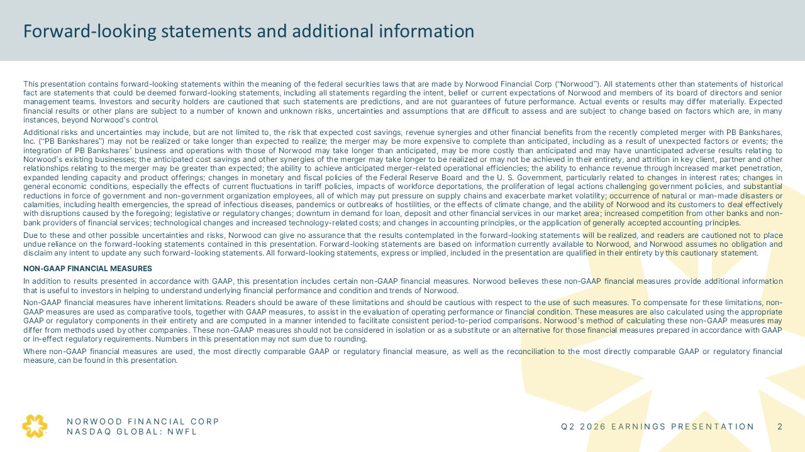
NORWOOD FINANCIAL CORP NASDAQ GLOBAL: NWFL Forward-looking statements and additional information This presentation contains forward-looking statements within the meaning of the federal securities laws that are made by Norwood Financial Corp (“Norwood”). All statements other than statements of historical fact are statements that could be deemed forward-looking statements, including all statements regarding the intent, belief or current expectations of Norwood and members of its board of directors and senior management teams. Investors and security holders are cautioned that such statements are predictions, and are not guarantees of future performance. Actual events or results may differ materially. Expected financial results or other plans are subject to a number of known and unknown risks, uncertainties and assumptions that are difficult to assess and are subject to change based on factors which are, in many instances, beyond Norwood’s control. Additional risks and uncertainties may include, but are not limited to, the risk that expected cost savings, revenue synergies and other financial benefits from the recently completed merger with PB Bankshares, Inc. (“PB Bankshares”) may not be realized or take longer than expected to realize; the merger may be more expensive to complete than anticipated, including as a result of unexpected factors or events; the integration of PB Bankshares’ business and operations with those of Norwood may take longer than anticipated, may be more costly than anticipated and may have unanticipated adverse results relating to Norwood’s existing businesses; the anticipated cost savings and other synergies of the merger may take longer to be realized or may not be achieved in their entirety, and attrition in key client, partner and other relationships relating to the merger may be greater than expected; the ability to achieve anticipated merger-related operational efficiencies; the ability to enhance revenue through increased market penetration, expanded lending capacity and product offerings; changes in monetary and fiscal policies of the Federal Reserve Board and the U. S. Government, particularly related to changes in interest rates; changes in general economic conditions, especially the effects of current fluctuations in tariff policies, impacts of workforce deportations, the proliferation of legal actions challenging government policies, and substantial reductions in force of government and non-government organization employees, all of which may put pressure on supply chains and exacerbate market volatility; occurrence of natural or man-made disasters or calamities, including health emergencies, the spread of infectious diseases, pandemics or outbreaks of hostilities, or the effects of climate change, and the ability of Norwood and its customers to deal effectively with disruptions caused by the foregoing; legislative or regulatory changes; downturn in demand for loan, deposit and other financial services in our market area; increased competition from other banks and non-bank providers of financial services; technological changes and increased technology-related costs; and changes in accounting principles, or the application of generally accepted accounting principles. Due to these and other possible uncertainties and risks, Norwood can give no assurance that the results contemplated in the forward-looking statements will be realized, and readers are cautioned not to place undue reliance on the forward-looking statements contained in this presentation. Forward-looking statements are based on information currently available to Norwood, and Norwood assumes no obligation and disclaim any intent to update any such forward-looking statements. All forward-looking statements, express or implied, included in the presentation are qualified in their entirety by this cautionary statement. NON-GAAP FINANCIAL MEASURES In addition to results presented in accordance with GAAP, this presentation includes certain non-GAAP financial measures. Norwood believes these non-GAAP financial measures provide additional information that is useful to investors in helping to understand underlying financial performance and condition and trends of Norwood. Non-GAAP financial measures have inherent limitations. Readers should be aware of these limitations and should be cautious with respect to the use of such measures. To compensate for these limitations, non-GAAP measures are used as comparative tools, together with GAAP measures, to assist in the evaluation of operating performance or financial condition. These measures are also calculated using the appropriate GAAP or regulatory components in their entirety and are computed in a manner intended to facilitate consistent period-to-period comparisons. Norwood’s method of calculating these non-GAAP measures may differ from methods used by other companies. These non-GAAP measures should not be considered in isolation or as a substitute or an alternative for those financial measures prepared in accordance with GAAP or in-effect regulatory requirements. Numbers in this presentation may not sum due to rounding. Where non-GAAP financial measures are used, the most directly comparable GAAP or regulatory financial measure, as well as the reconciliation to the most directly comparable GAAP or regulatory financial measure, can be found in this presentation. NORWOOD FINANCIAL CORP NASDAQ GLOBAL: NWFL Q2 2026 INVESTOR PRESENTATION 2

﻿
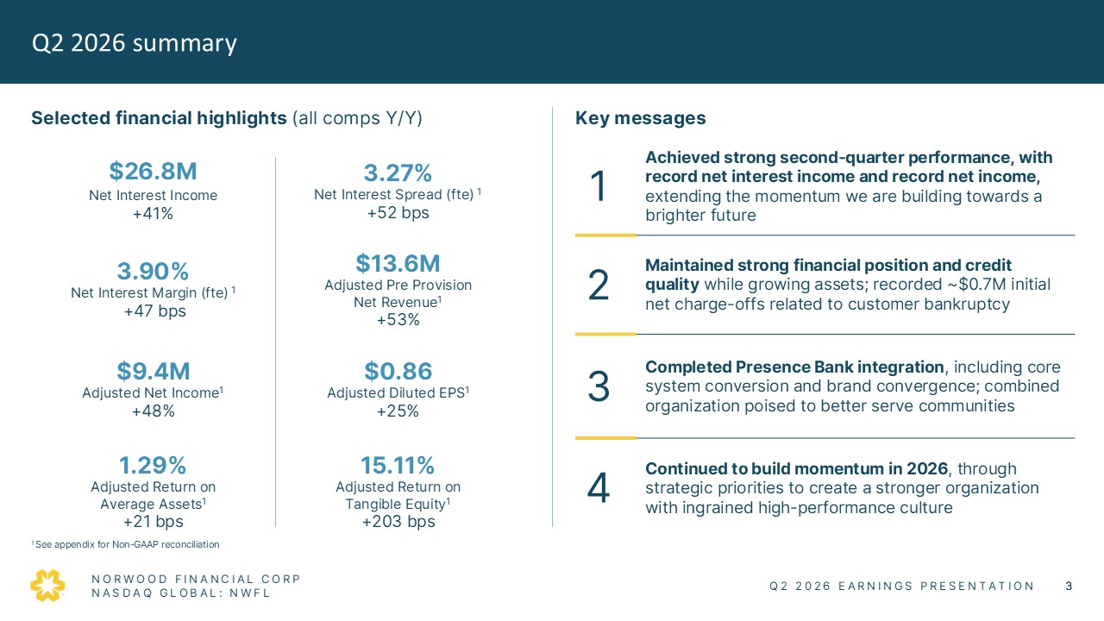
Q2 2026 summary Selected financial highlights (all comps Y/Y) $26.8M Net Interest Income +41% 3.90% Net Interest Margin (fte) +22bps $9.4M Adjusted Net Income +53% 1.28% Adjusted Return on Average Assets +22bps 3.27% Net Interest Spread (fte) +23 bps $13.6M Adjusted Pre Provision Net Revenue +53% $0.86 Adjusted Diluted EPS +28% 15.28% Adjsuted Return on Tangible Equity +220 bps Key messages 1 Achieved strong second-quarter performance, including record net interest income, extending the momentum we are building towards a bright future 2 Maintained strong financial position and credit quality while growing assets; recorded ~$1.4M initial net charge-offs related to customer bankruptcy 3 Completed Presence Bank integration, including core system conversion, and brand convergence; combined organization poised to better serve communities 4 Continued to build momentum in 2026, through strategic priorities to create a stronger organization with ingrained high-performance culture 1 See appendix for Non-GAAP reconciliation NORWOOD FINANCIAL CORP NASDAQ GLOBAL: NWFL Q2 2026 INVESTOR PRESENTATION 3

﻿

Making progress on our 2026 strategic priorities Focused on actions that will create value and build momentum Successfully complete Presence Bank integration • Completed key integration activity, including core system conversion and brand convergence • Ongoing dialogue to share best practices as we continue to standardize on operations and customer engagement Increase operating efficiency and elevate the customer experience through AI • Implemented PB commercial system to drive efficiency, manage risk, and empower employees to do more • Utilize AI embedded in PB processes across the organization as part of integration • Assess AI implementation and pursue highest value opportunities Strengthen our talent pool and deepen our leadership bench • Invest in our people to empower them to serve our communities • Cascade strategic priorities throughout organization • Steve Daniels, Executive Vice President and former Chief Consumer Banking Officer, has assumed role or Chief Lending Officer, assuming role previously held by Vinny O’Bell who is retiring in October 2026 Increase shareholder value • Delivered strong Q2 results on strong financial position and performance of our entire team • Grew asset base through increasing deposits, investment decisions, and strategic M&A • Enhance shareholder returns through a reliable and growing dividend NORWOOD FINANCIAL CORP NASDAQ GLOBAL: NWFL Q2 2026 INVESTOR PRESENTATION 4

﻿
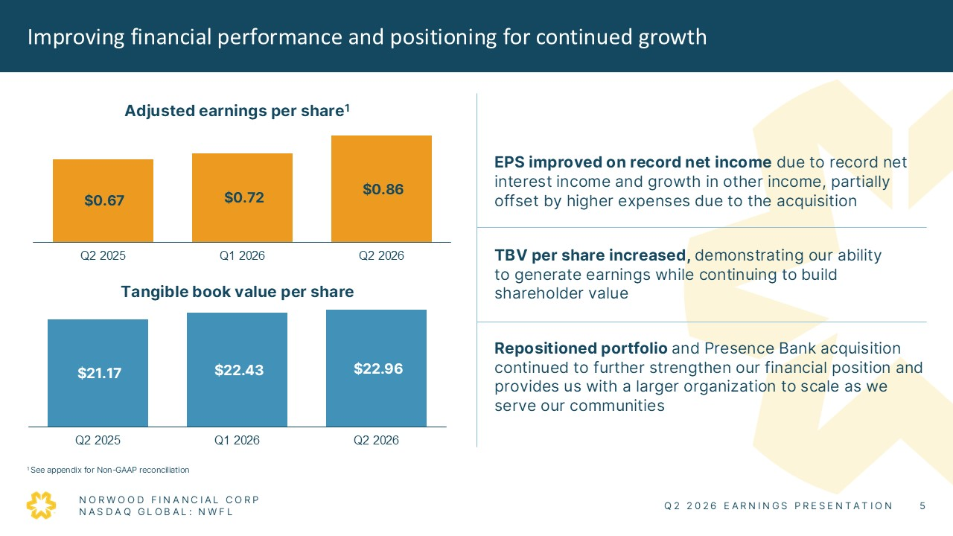
Improving financial performance and positioning for continued growth Adjusted earnings per share $0.67 $0.72 $0.86 Q2 2025 Q1 2026 Q2 2026 Tangible book value per share $21.17 $22.43 $22.97 Q2 2025 Q1 2026 Q2 2026 EPS improved due to record net interest income and growth in other income, partially offset by higher expenses due to the acquisition TBV per share increased demonstrating our ability to generate earnings while continuing to build shareholder value Repositioned portfolio and Presence Bank acquisition continued to further strengthen our financial position and provides us with a larger organization to scale as we serve our communities 1 See appendix for Non-GAAP reconciliation NORWOOD FINANCIAL CORP NASDAQ GLOBAL: NWFL Q2 2026 INVESTOR PRESENTATION 5

﻿
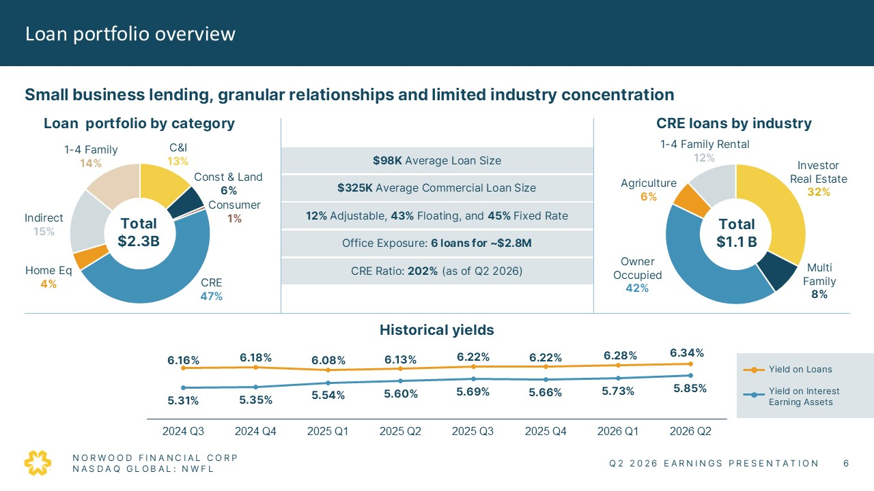
Loan portfolio overview Small business lending, granular relationships and limited industry concentration Loan portfolio by category 1-4 Family 14% C&I 13% Const & Land 6% Consumer 1% CRE 47% Home q 4% Indirect 15% Total$2.3B Historical asset yields 6.16% 6.18% 6.08% 6.13% 6.22% 6.22% 6.28% 6.34% 5.31% 5.35% 5.54% 5.60% 5.69% 5.66% 5.73% 5.85% 2024 Q3 2024 Q4 2025 Q1 2025 Q2 2025 Q3 2025 Q4 2026 Q1 2026 Q2 CRE loans by industry 1-4 Family Rental 12% Investor Real Estate 32% Multi Family 8% Owner Occupied 42% Agriculture 6% Total $1.1B $98K Average Loan Size $325K Average Commercial Loan Size 12% Adjustable, 43% Floating, and 45% Fixed Rate Office Exposure: 7 loans for ~$4.2M CRE Ratio: 202% (as of Q2 2026) NORWOOD FINANCIAL CORP NASDAQ GLOBAL: NWFL Q2 2026 INVESTOR PRESENTATION 6

﻿
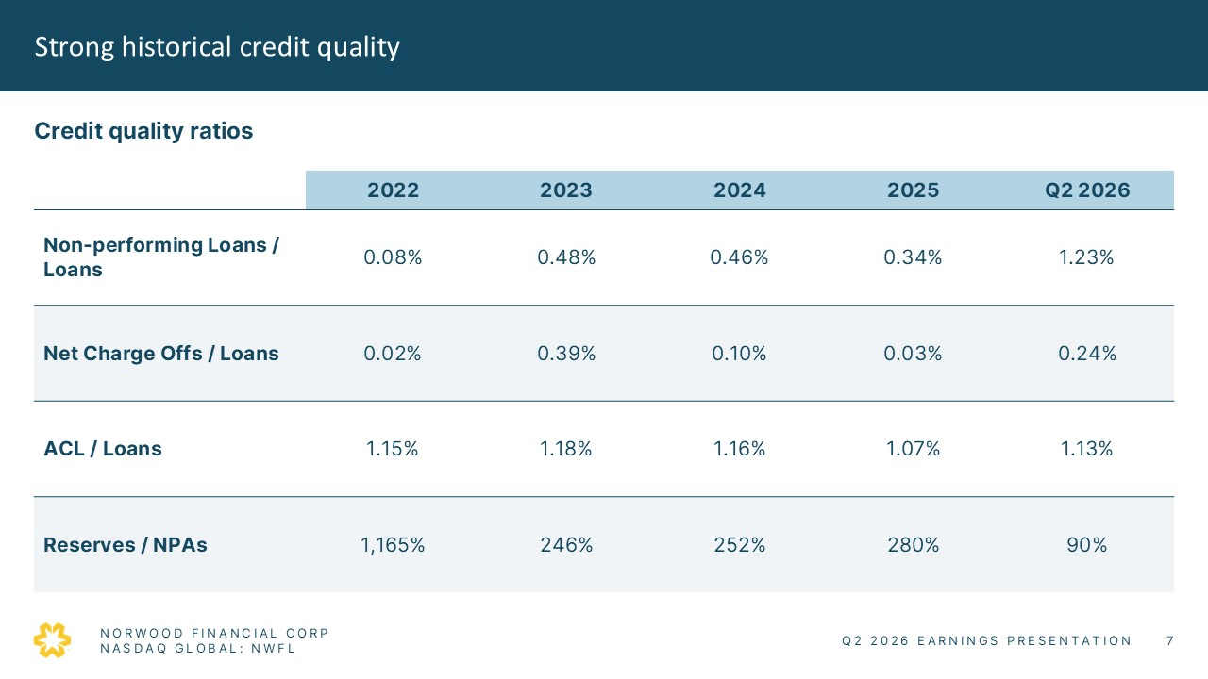
Strong historical credit quality Credit quality ratios 2022 2023 2024 2025 Q2 2026 Non-performing Loans / Loans 0.08% 0.48% 0.46% 0.34% 1.23% Net Charge Offs / Loans 0.02% 0.39% 0.10% 0.03% 0.24% ACL / Loans 1.15% 1.18% 1.16% 1.07% 1.13% Reserves / NPAs 1,165% 246% 252% 280% 90% NORWOOD FINANCIAL CORP NASDAQ GLOBAL: NWFL Q2 2026 INVESTOR PRESENTATION 7

﻿
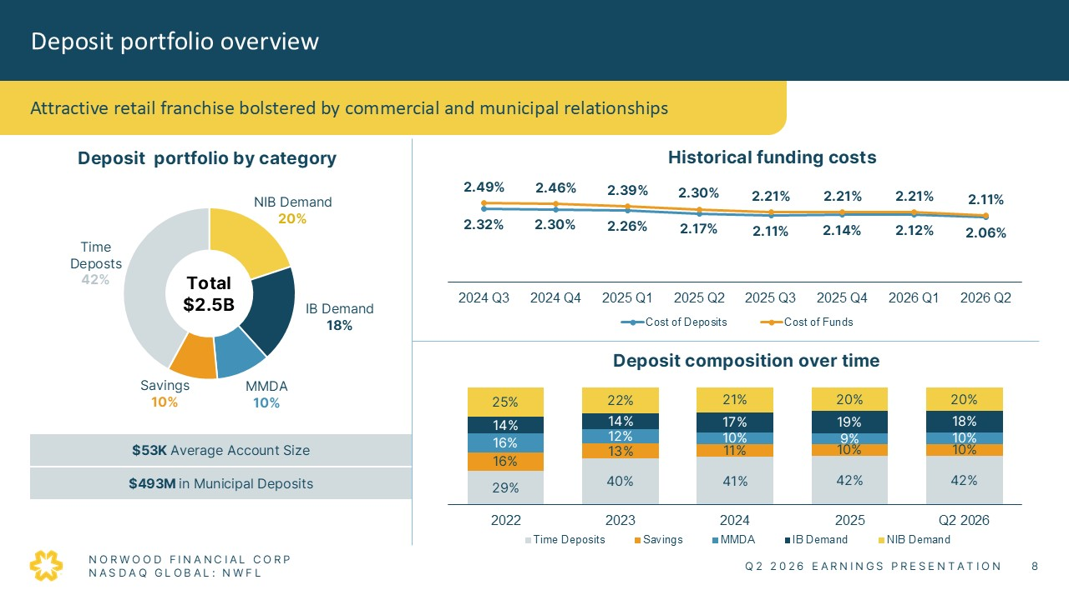
Attractive retail franchise bolstered by commercial and municipal relationships Deposit portfolio by category Time Deposts 42 NIB Demand 20% IB Demand 18% MMDA 10% Savings 10% Total $2.5B $53K Average Account Size $493M in Municipal Deposits Historical funding costs 2.49% 2.46% 2.39% 2.30% 2.21% 2.21% 2.21% 2.11% 2.32% 2.30% 2.26% 2.17% 2.11% 2.14% 2.12% 2.06% 2024 Q3 2024 Q4 2025 Q1 2025 Q2 2025 Q3 2025 Q4 2026 Q1 2026 Q2 Cost of Deposits Cost of funds Deposit composition over time 25% 22% 21% 20% 20% 14% 14% 17% 19% 18% 16% 12% 10% 9% 10% 16% 13% 11% 10% 10% 29% 40% 41% 42% 42% 2022 2023 2024 2025 Q2 2026 Time Deposits Savings MMDA IB Demand NIB Demand NORWOOD FINANCIAL CORP NASDAQ GLOBAL: NWFL Q2 2026 INVESTOR PRESENTATION 8

﻿
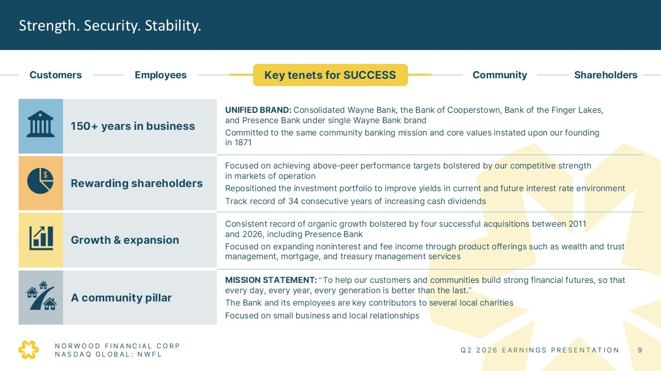
Strength. Security. Stability. Key tenets for SUCCESS Customers Shareholders Employees Community 150+ years in business UNIFIED BRAND: Consolidated Wayne Bank, the Bank of Cooperstown, Bank of the Finger Lakes, and Presence Bank under single Wayne Bank brand Committed to the same community banking mission and core values instated upon our founding in 1871 Rewarding shareholders Focused on achieving above-peer performance targets bolstered by our competitive strength in markets of operation Repositioned the investment portfolio to improve yields in current and future interest rate environment Track record of 34 consecutive years of increasing cash dividends Growth & expansion Consistent record of organic growth bolstered by four successful acquisitions between 2011 and 2026, including Presence Bank Focused on expanding noninterest and fee income through product offerings such as wealth and trust management, mortgage, and treasury management services A community pillar MISSION STATEMENT: “To help our customers and communities build strong financial futures, so that every day, every year, every generation is better than the last.” The Bank and its employees are key contributors to several local charities Focused on small business and local relationships NORWOOD FINANCIAL CORP NASDAQ GLOBAL: NWFL Q2 2026 INVESTOR PRESENTATION 9

﻿

APPENDIX NORWOOD FINANCIAL CORP NASDAQ GLOBAL: NWFL Q2 2026 INVESTOR PRESENTATION 10

﻿
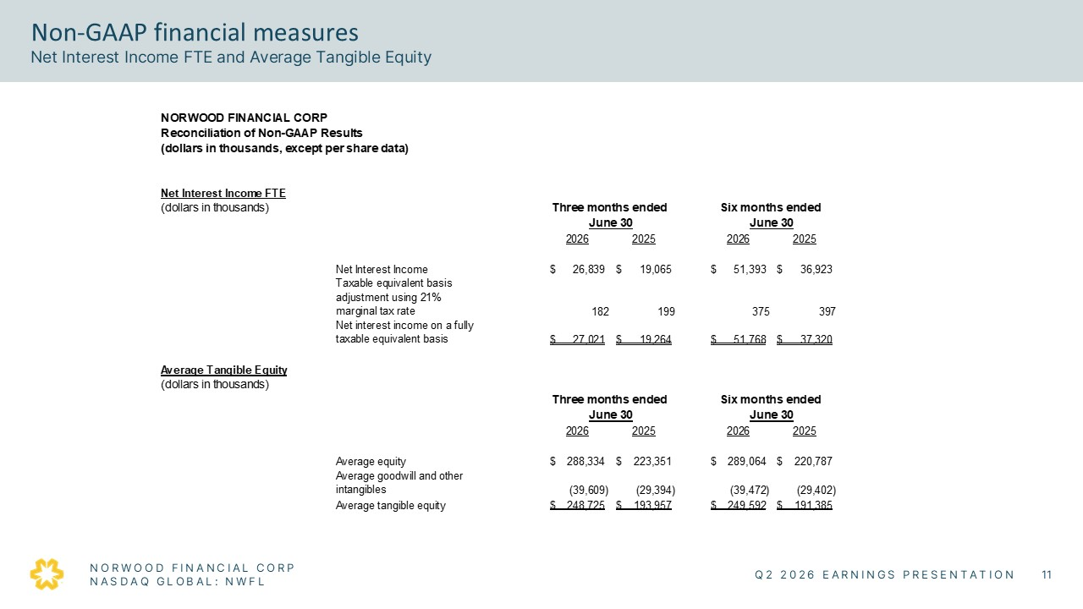
Non-GAAP financial measures Net Interest Income FTE and Average Tangible Equity NORWOOD FINANCIAL CORP Reconciliation of Non-GAAP Results (dollars in thousands, except per share data) Net Interest Income FTE (dollars in thousands) Three months ended Six months ended June 30 June 30 2026 2025 2026 2025 Net Interest Income $26,839 $19,065 $51,393 $36,923 Taxable equivalent basis adjustment using 21% marginal tax rate 182 199 375 397 Net interest income on a fully taxable equivalent basis $27,021 $19,264 $51,768 $37,320 Average Tangible Equity (dollars in thousands) Three months ended Six months ended June 30 June 30 2026 2025 2026 2025 Average equity $288,334 $223,351 $289,064 $220,787 Average goodwill and other intangibles (39,609) (29,394) (39,472) (29,402) Average tangible equity $248,725 $193,957 $249,592 $191,385 NORWOOD FINANCIAL CORP Q2 2026 INVESTOR PRESENTATION 12

﻿
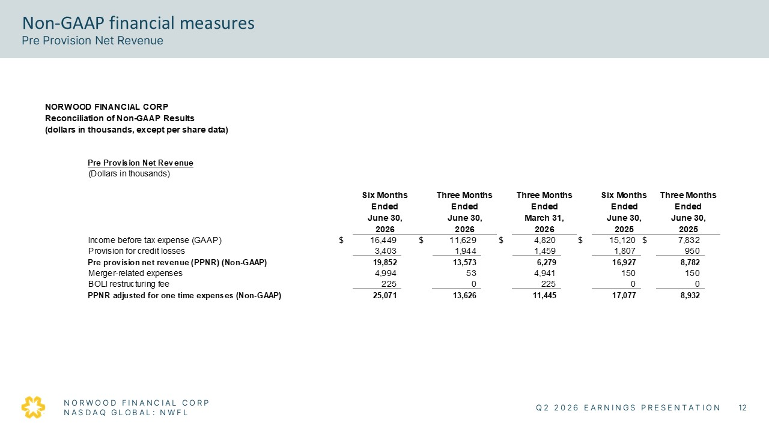
Non-GAAP financial measures Pre Provision Net Revenue NORWOOD FINANCIAL CORP Reconciliation of Non-GAAP Results (dollars in thousands, except per share data) Pre Provision Net Revenue (Dollars in thousands) Six Months Three Months Three Months Six Months Three Months Ended Ended Ended Ended Ended June 30, June 30, March 31, June 30, June 30, 2026 2026 2026 2025 2025 Income before tax expense (GAAP) $ 16,449 $ 11,629 $ 4,820 $ 15,120 $ 7,832 Provision for credit losses 3,403 1,944 1,459 1,807 950 Pre provision net revenue (PPNR) (Non-GAAP) 19,852 13,573 6,279 16,927 8,782 Merger-related expenses 4,994 53 4,941 150 150 BOLI restructuring fee 225 0 225 0 0 PPNR adjusted for one time expenses (Non-GAAP) 25,071 13,626 11,445 17,077 8,932 NORWOOD FINANCIAL CORP Q2 2026 INVESTOR PRESENTATION 13

﻿
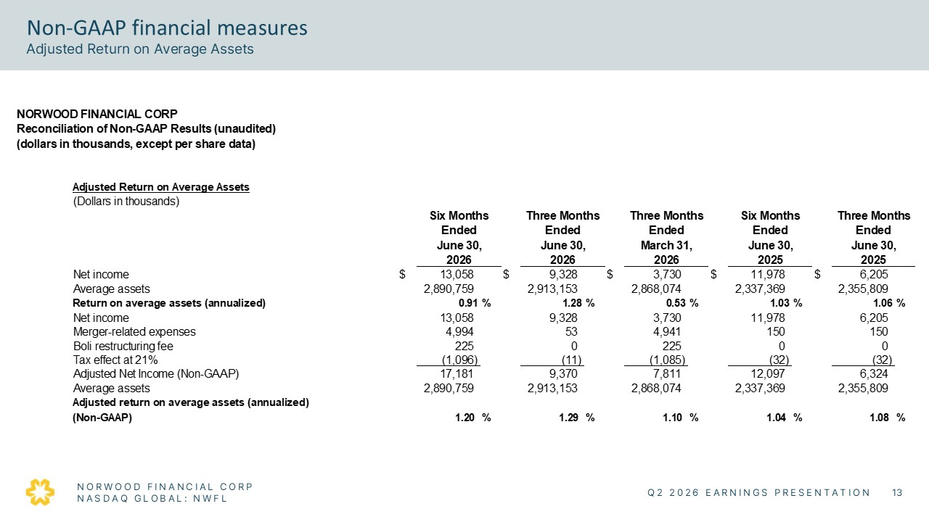
Non-GAAP financial measures Adjusted Return on Average Assets NORWOOD FINANCIAL CORP Reconciliation of Non-GAAP Resutls (Dollars in thousands, except per share date) Adjusted Returnon Average Tangible Shareholders' Equity (Dollar in thousands) Six Months Three Months Three Months Six Months Three Months Ended Ended Ended Ended Ended June 30, June 30, March 31, June 30, June 30, 2026 2026 2026 2025 2025 Net income $13,058 $9,328 $3,730 $11,978 $6,205 Average assets 289,064 2,913,153 2,868,074 2,337,369 2,355,809 Return on average assets (annualized) 0.91% 1.28% 0.53% 1.03% 1.06% Net income 13,058 9,328 3,730 11,978 6,205 Merger-related expneses 4,994 53 4,941 150 150 Boli restructuring fee 225 — 225 — — Tax effect at 21% (1,096) (11) (1,085) (32) (32) Adjuste Net Income (Non-GAAP) 17,181 9,370 7,811 12,097 6,324 Average assets 2,890,759 2,913,153 2,868,074 2,337,369 2,355,809 Adjusted returnon average shareholders' equity (annualized) (Non-GAAP) 1.20% 1.29% 1.10% 1.04% 1.08% NORWOOD FINANCIAL CORP Q2 2026 INVESTOR PRESENTATION 14

﻿
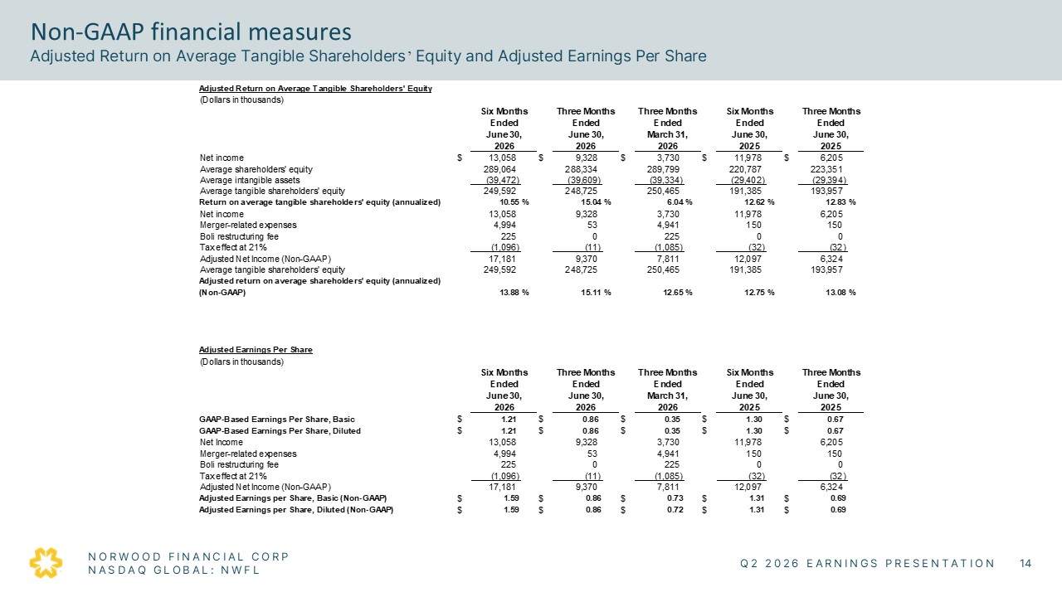
Non-GAAP financial measures Net Interest Income FTE and Average Tangible Equity NORWOOD FINANCIAL CORP Reconciliation of Non-GAAP Results (dollars in thousands, except per share data) Net Interest Income FTE (dollars in thousands) Three months ended Six months ended June 30 June 30 2026 2025 2026 2025 Net Interest Income $ 26,839 $ 19,065 $ 51,393 $ 36,923 Taxable equivalent basis adjustment using 21% marginal tax rate 182 199 375 397 Net interest income on a fully taxable equivalent basis $ 27,021 $ 19,264 $ 51,768 $ 37,320 Average Tangible Equity (dollars in thousands) Three months ended Six months ended June 30 June 30 2026 2025 2026 2025 Average equity $ 288,334 $ 223,351 $ 289,064 $ 220,787 Average goodwill and other intangibles (39,609) (29,394) (39,472) (29,402) Average tangible equity $ 248,725 $ 193,957 $ 249,592 $ 191,385 NORWOOD FINANCIAL CORP Q2 2026 INVESTOR PRESENTATION 12 Non-GAAP financial measures Pre Provision Net Revenue NORWOOD FINANCIAL CORP Reconciliation of Non-GAAP Results (dollars in thousands, except per share data) Pre Provision Net Revenue (Dollars in thousands) Six Months Three Months Three Months Six Months Three Months Ended Ended Ended Ended Ended June 30, June 30, March 31, June 30, June 30, 2026 2026 2026 2025 2025 Income before tax expense (GAAP) $ 16,449 $ 11,629 $ 4,820 $ 15,120 $ 7,832 Provision for credit losses 3,403 1,944 1,459 1,807 950 Pre provision net revenue (PPNR) (Non-GAAP) 19,852 13,573 6,279 16,927 8,782 Merger-related expenses 4,994 53 4,941 150 150 BOLI restructuring fee 225 0 225 0 0 PPNR adjusted for one time expenses (Non-GAAP) 25,071 13,626 11,445 17,077 8,932 NORWOOD FINANCIAL CORP Q2 2026 INVESTOR PRESENTATION 13 Non-GAAP financial measures Adjusted Return on Average Assets NORWOOD FINANCIAL CORP Reconciliation of Non-GAAP Results (dollars in thousands, except per shar data) Adjusted Returnon Average Assets (Dollars in thousands) Six Months Three Months Three Months Six Months Three Months Ended Ended Ended Ended Ended June 30, June 30, March 31, June 30, June 30, 2026 2026 2026 2025 2025 Net income $13,058 $9,328 $3,730 $11,978 $6,205 Average assets 2,890,759 2,913,153 2,868,074 2,337,369 2,355,809 Returnon average assets (annualized) 0.91% 1.28% 0.53% 1.03% 1.06% net income 13,058 9,328 3,730 11,978 6,205 Merger-related epxenses 4,994 533 4,941 150 150 Boli restructuring fee 225 — 225 — — Tax effect at 21% (1,098) (1) (1,085) (32) (32) Adjuste Net Income (Non-GAAP) 17,180 9,370 7,811 12,097 6,324 Average assets 2,890,759 2,913,153 2,868,074 2,337,369 2,355,809 Adjsuted reutrn on average assets (annualized) (Non-GAAP) 1.20% 1.29% 1.10% 1.04% 1.08% NORWOOD FINANCIAL CORP Q2 2026 INVESTOR PRESENTATION 14 Non-GAAP financial measures Adjusted Return on Average Tangible Shareholders’ Equity and Adjusted Earnings Per Share Adjusted Returnon Average Tangible Shareholders' Equity (Dollar in thousands) Six Months Three Months Three Months Six Months Three Months Ended Ended Ended Ended Ended June 30, June 30, March 31, June 30, June 30, 2026 2026 2026 2025 2025 Net income $13,058 $9,328 $3,730 $11,978 $6,205 Average shareholders' equity 289,064 288,334 289,799 220,787 223,351 Average intangible assets (39,472) (39,609) (39,334) (29,402) (29,394) Average tangible sahrehlders' equity 249,592 248,728 250,465 191,385 193,957 Returnon average tangible shareholders' equity (annualized) 10.55% 15.04% 6.04% 12.62% 25.10% Net income 13,058 9,328 3,730 11,978 6,205 Merger-related expneses 4,994 53 4,941 150 150 Boli restructuring fee 225 — 225 — — Tax effect at 21% (1,096) (11) (1,085) (32) (32) Adjuste Net Income (Non-GAAP) 17,181 9,370 7,811 12,097 6,324 Average tangible shareholders' equity 249,592 248,725 250,465 191,385 193,957 Adjusted returnon average shareholders' equity (annualized) (Non-GAAP) 13.88% 15.11% 12.65% 12.75% 25.35% Adjusted Eearnings Per Share (Dollars in thousadns) Six Months Three Months Three Months Six Months Three Months Ended Ended Ended Ended Ended June 30, June 30, March 31, June 30, June 30, 2026 2026 2026 2025 2025 GAAP- Based Earnings Pe Share, Basic $1.21 $0.86 $0.35 $1.30 $0.67 GAAP- Based Earnings Pe Share, Diluted $1.21 $0.86 $0.35 $1.30 $0.67 Net Income 13,058 9,328 3,730 11,978 6,205 Merger-realted expneses 4,994 53 4,941 150 150 Boli reconstructuring fee 225 — 225 — — Tax effect at 21% (1,096) (11) (1,085) (32) (32) Adjusted Net Income (Non- GAAP) 17,181 9,370 7,811 12,097 6,324 Adjusted Earnings per Sahre, Basic (Non-GAAP) $1.59 $0.86 $0.73 $1.31 $0.69 Adjusted Earnings per Sahre, Diluted (Non-GAAP) $1.59 $0.86 $0.72 $1.31 $0.69 NORWOOD FINANCIAL CORP Q2 2026 INVESTOR PRESENTATION 15

﻿

Thank you

